JavaServer Faces

CHAPTER

39





Objectives
- To explain what JSF is (§39.1).
- To create a JSF project in NetBeans (§39.2.1).
- To create a JSF page (§39.2.2).
- To create a JSF managed bean (§39.2.3).
- To use JSF expressions in a facelet (§39.2.4).
- To use JSF GUI components (§39.3).
- To obtain and process input from a form (§39.4).
- To develop a calculator using JSF (§39.5).
- To track sessions in application, session, view, and request scopes (§39.6).
- To validate input using the JSF validators (§39.7).
- To bind database with facelets (§39.8).
- To open a new JSF page from the current page (§39.9).
- To program using contexts and dependency injection (§39.10).

39-2 Chapter 39 JavaServer Faces

Introduction

Key Point
JavaServer Faces (JSF) is a new technology for developing server-side Web applications using Java.


JSF

JSF 2 XHTML CSS

NetBeans 7.3.1
GlassFish 4
Java EE 7

Key Point


create a project

choose server and Java EE 7
JSF enables you to completely separate Java code from HTML. You can quickly build Web applications by assembling reusable UI components in a page, connecting these components to Java programs and wiring client-generated events to server-side event handlers. The applica- tion developed using JSF is easy to debug and maintain.


Note
This chapter introduces JSF 2, the latest standard for JavaServer Faces. You need to know XHTML (eXtensible HyperText Markup Language) and CSS (Cascading Style Sheet) to start this chapter. For information on XHTML and CSS, see Supplements V.A and V.B on the Companion Website.


Caution
The examples and exercises in this chapter were tested using NetBeans 7.3.1, GlassFish 4, and Java EE 7. You need to use NetBeans 7.3.1 or a higher version with GlassFish 4 and Java EE 7 to develop your JSF projects.

Getting Started with JSF
NetBeans is an effective tool for developing JSF applications.
We begin with a simple example that illustrates the basics of developing JSF projects using NetBeans. The example is to display the date and time on the server, as shown in Figure 39.1.
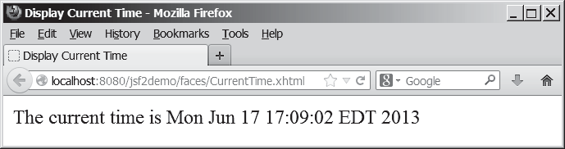
FIGuRE 39.1 The application displays the date and time on the server.

Creating a JSF Project
Here are the steps to create the application.
Step 1: Choose File, New Project to display the New Project dialog box. In this box, choose Java Web in the Categories pane and Web Application in the Projects pane. Click Next to display the New Web Application dialog box.
In the New Web Application dialog box, enter and select the following fields, as shown in Figure 39.2a:
Project Name: jsf2demo
Project Location: c:\book
Step 2: Click Next to display the dialog box for choosing servers and settings. Select the following fields as shown in Figure 39.2b. (Note: You can use any server such as Glass- Fish 4.x that supports Java EE 6.)
Server: GlassFish 4
Java EE Version: Java EE 7 Web

39.2 Getting Started with JSF 39-3

Step 3: Click Next to display the dialog box for choosing frameworks, as shown in Figure 39.3. Check JavaServer Faces and JSF 2.0 as Server Library. Click Finish to create the project, as shown in Figure 39.4.
choose JavaServer Faces and JSF2.2

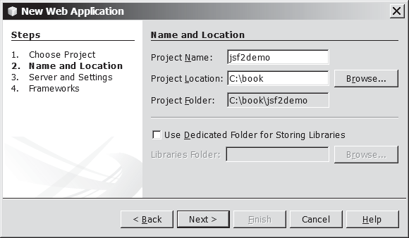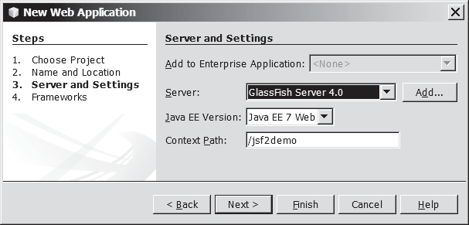
(a) (b)
FIGuRE 39.2 The New Web Application dialog box enables you to create a new Web project.

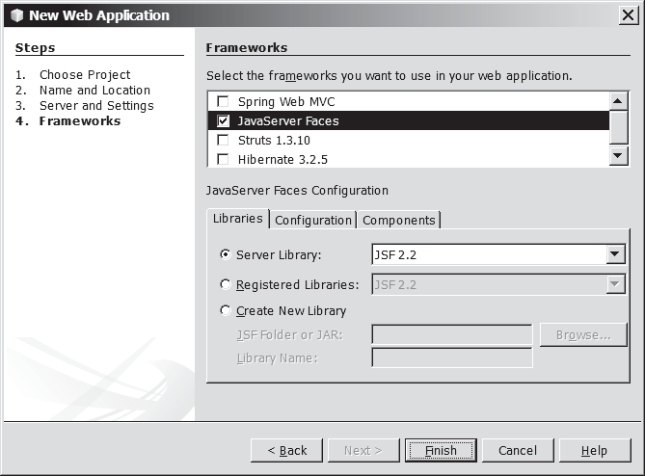
FIGuRE 39.3 Check JavaServer Faces and JSF 2.2 to create a Web project.


A Basic JSF Page
A new project was just created with a default page named index.xhtml, as shown in Figure 39.4. This page is known as a facelet, which mixes JSF tags with XHTML tags. Listing 39.1 lists the contents of index.xhtml.
LISTING 39.1 index.xhtml
      - <?xml version='1.0' encoding='UTF-8' ?>
      - <!-- index.xhtml -->
      - <!DOCTYPE html PUBLIC "-//W3C//DTD XHTML 1.0 Transitional//EN"
      - "http://www.w3.org/TR/xhtml1/DTD/xhtml1-transitional.dtd">
      - <html xmlns="http://www.w3.org/1999/xhtml"
      - xmlns:h="http://xmlns.jcp.org/jsf/html">

facelet

xml version comment DOCTYPE

default namespace JSF namespace

39-4 Chapter 39 JavaServer Faces
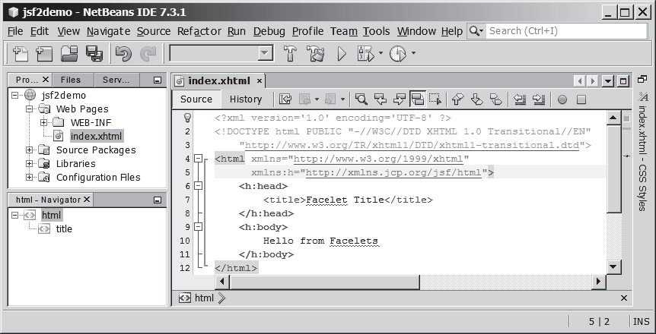
FIGuRE 39.4 A default JSF page is created in a new Web project.


h:head | 7 | <h:head>
 | 8 | <title>Facelet Title</title>
 | 9 | </h:head>
h:body | 10 | <h:body>
 | 11 | Hello from Facelets
 | 12 | </h:body>
 | 13 | </html>


XML declaration

XML comment DOCTYPE
element tag

html tag
Line 1 is an XML declaration to state that the document conforms to the XML version 1.0 and uses the UTF-8 encoding. The declaration is optional, but it is a good practice to use it. A docu- ment without the declaration may be assumed of a different version, which may lead to errors. If an XML declaration is present, it must be the first item to appear in the document. This is because an XML processor looks for the first line to obtain information about the document so that it can be processed correctly.
Line 2 is a comment for documenting the contents in the file. XML comment always begins with <!-- and ends with -->.
Lines 3 and 4 specify the version of XHTML used in the document. This can be used by the Web browser to validate the syntax of the document.
An XML document consists of elements described by tags. An element is enclosed between a start tag and an end tag. XML elements are organized in a tree-like hierarchy. Elements may con- tain subelements, but there is only one root element in an XML document. All the elements must be enclosed inside the root tag. The root element in XHTML is defined using the html tag (line 5). Each tag in XML must be used in a pair of the start tag and the end tag. A start tag begins with < followed by the tag name and ends with >. An end tag is the same as its start tag except
that it begins with </. The start tag and end tag for html are <html> and </html>.
The html element is the root element that contains all other elements in an XHTML page. The starting <html> tag (lines 5 and 6) may contain one or more xmlns (XML namespace) attributes to specify the namespace for the elements used in the document. Namespaces are like Java packages. Java packages are used to organize classes and to avoid naming conflict. XHTML namespaces are used to organize tags and resolve naming conflict. If an element with the same name is defined in two namespaces, the fully qualified tag names can be used to differentiate them.

39.2 Getting Started with JSF 39-5

Each xmlns attribute has a name and a value separated by an equal sign (=). The following declaration (line 5)

xmlns="http://www.w3.org/1999/xhtml"

specifies that any unqualified tag names are defined in the default standard XHTML namespace.
The following declaration (line 6)

xmlns:h="http://xmlns.jcp.org/jsf/html"

allows the tags defined in the JSF tag library to be used in the document. These tags must have a prefix h.
An html element contains a head and a body. The h:head element (lines 7–9) defines an HTML title element. The title is usually displayed in the browser window’s title bar.
An h:body element defines the page’s content. In this simple example, it contains a string to be displayed in the Web browser.


Note
The XML tag names are case sensitive, whereas HTML tags are not. So, <html> is differ- ent from <HTML> in XML. Every start tag in XML must have a matching end tag, whereas some tags in HTML do not need end tags.

You can now display the page in index.xhtml by right-clicking on index.xhtml in the projects pane and choose Run File. The page is displayed in a browser, as shown in Figure 39.5.
xmlns

h:head h:body

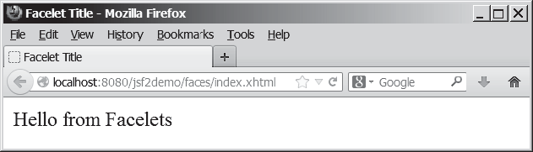
FIGuRE 39.5 The index.xhtml is displayed in the browser.



Note
The JSF page is processed and converted into a regular HTML page for displaying by a browser. The Java software that runs on the server side for producing the HTML page is known as Java server container or simply container. The container is responsible for handling all server-side tasks for Java EE. GlassFish is a Java server container.

Managed JavaBeans for JSF
JSF applications are developed using the Model-View-Controller (MVC) architecture, which separates the application’s data (contained in the model) from the graphical presentation (the view). The controller is the JSF framework that is responsible for coordinating interactions between view and the model.
In JSF, the facelets are the view for presenting data. Data are obtained from Java objects. Objects are defined using Java classes. In JSF, the objects that are accessed from a facelet are JavaBeans objects. A JavaBean class is simply a public Java class with a no-arg constructor. JavaBeans may contain properties. By convention, a property is defined with a getter and a setter method. If a property only has a getter method, the property is called a read-only prop- erty. If a property only has a setter method, the property is called a write-only property. A property does not need to be defined as a data field in the class.

container

JavaBean



39-6 Chapter 39 JavaServer Faces
Our example in this section is to develop a JSF facelet to display current time. We will cre- ate a JavaBean with a getTime() method that returns the current time as a string. The facelet will invoke this method to obtain current time.
Here are the steps to create a JavaBean named TimeBean.
Step 1. Right-click the project node jsf2demo to display a context menu as shown in Figure 39.6. Choose New, JSF Managed Bean to display the New JSF Managed Bean dialog box, as shown in Figure 39.7. (Note: if you don’t see JSF Managed Bean in the menu, choose Other to locate it in the JavaServer Faces category.)
Step 2. Enter and select the following fields, as shown in Figure 39.7: Class Name: TimeBean
Package: jsf2demo
Name: timeBean
Scope: request
Click Finish to create TimeBean.java, as shown in Figure 39.8.
Step 3. Add the getTime() method to return the current time, as shown in Listing 39.2.

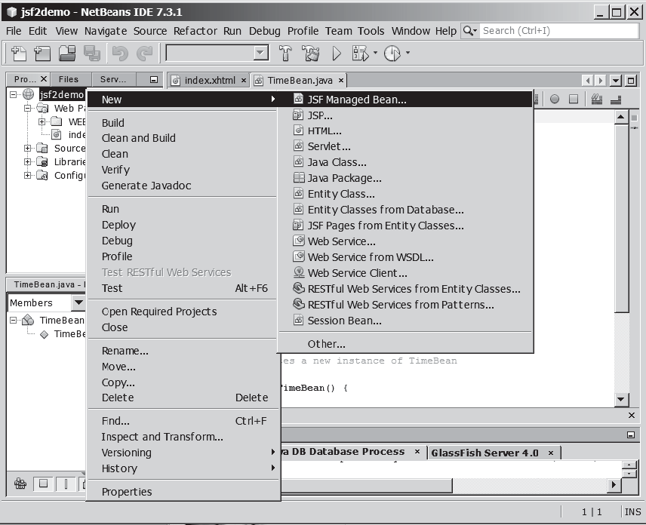
FIGuRE 39.6 Choose JSF Managed Bean to create a JavaBean for JSF.



Getting Started with JSF 39-7
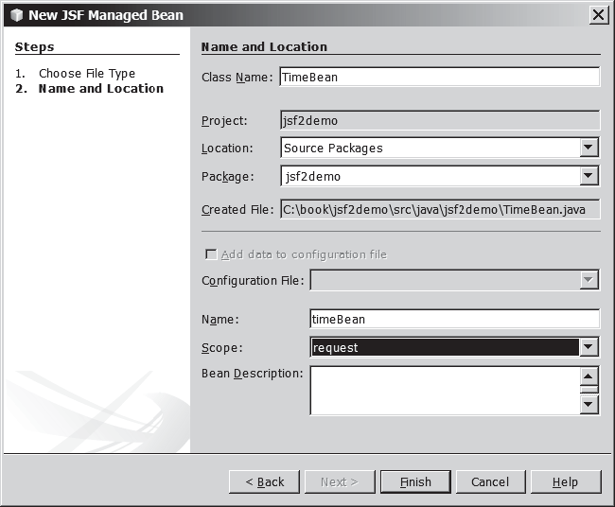
FIGuRE 39.7 Specify the name, location, and scope for the bean.



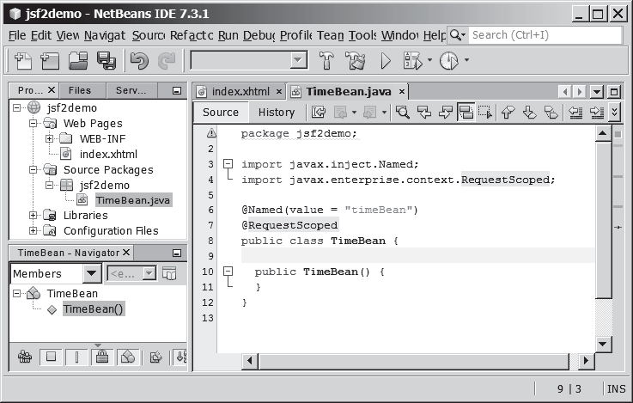
FIGuRE 39.8 A JavaBean for JSF was created.

39-8 Chapter 39 JavaServer Faces
Listing 39.2 TimeBean.java
1 package jsf2demo;
2
- import javax.inject.Named;
- import javax.enterprise.context.RequestScoped;
5


@Named @RequestScoped

time property

@RequestScope



refresh page

JSF expression
6
7
@Named (value = "timeBean") @RequestScoped
- public class TimeBean {
- public TimeBean() {
- }
11
- public String getTime() {
- return new java.util.Date().toString();
14 }
15 }

TimeBean is a JavaBeans with the @Named annotation, which indicates that the JSF framework will create and manage the TimeBean objects used in the application. You have learned to use the @Override annotation in Chapter 11. The @Override annotation tells the compiler that the annotated method is required to override a method in a superclass. The @Named annotation tells the compiler to generate the code to enable the bean to be used by JSF facelets.
The @RequestScope annotation specifies that the scope of the JavaBeans object is within a request. You can also use @ViewScope, @SessionScope or @ApplicationScope to specify the scope for a session or for the entire application.

JSF Expressions
We demonstrate JSF expressions by writing a simple application that displays the current time. You can display current time by invoking the getTime() method in a TimeBean object using a JSF expression.
To keep index.xhtml intact, we create a new JSF page named CurrentTime.xhtml as follows:
Step 1. Right-click the jsf2demo node in the project pane to display a context menu and choose New, JSF Page to display the New JSF File dialog box, as shown in Figure 39.9.
Step 2. Enter CurrentTime in the File Name field, choose Facelets and click Finish to generate CurrentTime.xhtml, as shown in Figure 39.10.
Step 3. Add a JSF expression to obtain the current time, as shown in Listing 39.3.
Step 4. Right-click on CurrentTime.xhtml in the project to display a context menu and choose Run File to display the page in a browser as shown in Figure 39.1.
LISTING 39.3 CurrentTime.xhtml
      - <?xml version='1.0' encoding='UTF-8' ?>
      - <!DOCTYPE html PUBLIC "-//W3C//DTD XHTML 1.0 Transitional//EN"
      - "http://www.w3.org/TR/xhtml1/DTD/xhtml1-transitional.dtd">
      - <html xmlns="http://www.w3.org/1999/xhtml"
      - xmlns:h="http://xmlns.jcp.org/jsf/html">
      - <h:head>
      - <title>Display Current Time</title>
      - <meta http-equiv="refresh" content ="60" />
      - </h:head>
      - <h:body>
      - The current time is #{timeBean.time}
      - </h:body>
      - </html>

Getting Started with JSF 39-9
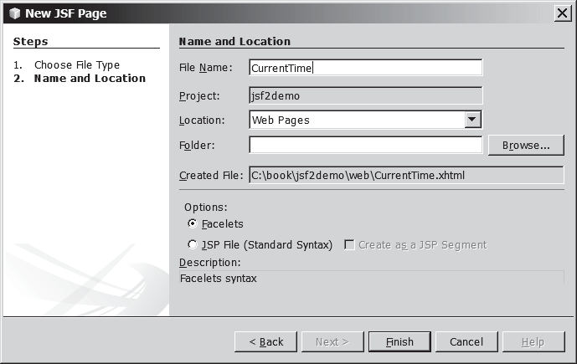
FIGuRE 39.9 The New JSF Page dialog is used to create a JSF page.

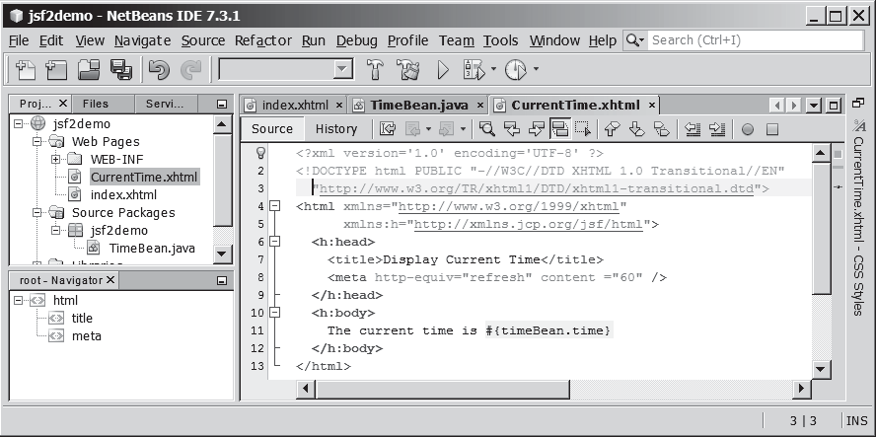
FIGuRE 39.10 A New JSF page CurrentTime was created.


Line 11 defines a meta tag inside the h:head tag to tell the browser to refresh every 60 seconds. This line can also be written as

<meta http-equiv="refresh" content ="60"></ meta>

An element is called an empty element if there are no contents between the start tag and the end tag. In an empty element, data are typically specified as attributes in the start tag. You can close an empty element by placing a slash immediately preceding the start tag’s right angle bracket, as shown in line 8, for brevity.

empty element

39-10 Chapter 39 JavaServer Faces





jsf core namespace

graphicImage

Check Point
Line 8 uses a JSF expression #{timeBean.time} to obtain the current time. timeBean is an object of the TimeBean class. The object name can be changed in the @Named annotation (line 6 in Listing 39.2) using the following syntax:

@Named(name = "anyObjectName")

By default, the object name is the class name with the first letter in lowercase.
Note that time is a JavaBeans property because the getTime() method is defined in Time- Beans. The JSF expression can either use the property name or invoke the method to obtain the current time. So the following two expressions are fine.

#{timeBean.time} #{timeBean.getTime()}
The syntax of a JSF expression is

#{expression}

JSF expressions bind JavaBeans objects with facelets. You will see more use of JSF expres- sions in the upcoming examples in this chapter.
    - What is JSF?
    - How do you create a JSF project in NetBeans?
    - How do you create a JSF page in a JSF project?
    - What is a facelet?
    - What is the file extension name for a facelet?
    - What is a managed bean?
    - What is the @Named annotation for?
    - What is the @RequestScope annotation for?

JSF GUI Components

Key Point
JSF provides many elements for displaying GUI components.
Table 39.1 lists some of the commonly used elements. The tags with the h prefix are in the JSF HTML Tag library. The tags with the f prefix are in the JSF Core Tag library.
Listing 39.4 is an example that uses some of these elements to display a student registration form, as shown in Figure 39.11.
LISTING 39.4 StudentRegistrationForm.xhtml
- <?xml version='1.0' encoding='UTF-8' ?>
- <!DOCTYPE html PUBLIC "-//W3C//DTD XHTML 1.0 Transitional//EN"
- "http://www.w3.org/TR/xhtml1/DTD/xhtml1-transitional.dtd">
- <html xmlns="http://www.w3.org/1999/xhtml"
- xmlns:h="http://xmlns.jcp.org/jsf/html"
- xmlns:f="http://xmlns.jcp.org/jsf/core">
- <h:head>
- <title>Student Registration Form</title>
- </h:head>
- <h:body>
- <h:form>
- <!-- Use h:graphicImage -->
- <h3>Student Registration Form
- <h:graphicImage name="usIcon.gif" library="image"/>
15 </h3>



  - JSF GUI Components 39-11
TABLE 39.1 JSF GUI Form Elements

JSF Tag Description

h:form inserts an XHTML form into a page.
h:panelGroup similar to a JavaFX FlowPane.
h:panelGrid similar to a JavaFX GridPane.
h:inputText displays a textbox for entering input.
h:outputText displays a textbox for displaying output. h:inputTextArea displays a textarea for entering input. h:inputSecret displays a textbox for entering password. h:outputLabel displays a label.
h:outputLink displays a hypertext link.
h:selectOneMenu displays a combo box for selecting one item. h:selectOneRadio displays a set of radio button. h:selectManyCheckbox displays checkboxes.
h:selectOneListbox displays a list for selecting one item. h:selectManyListbox displays a list for selecting multiple items.
f:selectItem specifies an item in an h:selectOneMenu, h:selectOneRadio, or h:selectManyListbox.
h:message displays a message for validating input.
h:dataTable displays a data table.
h:column specifies a column in a data table.
h:graphicImage displays an image.

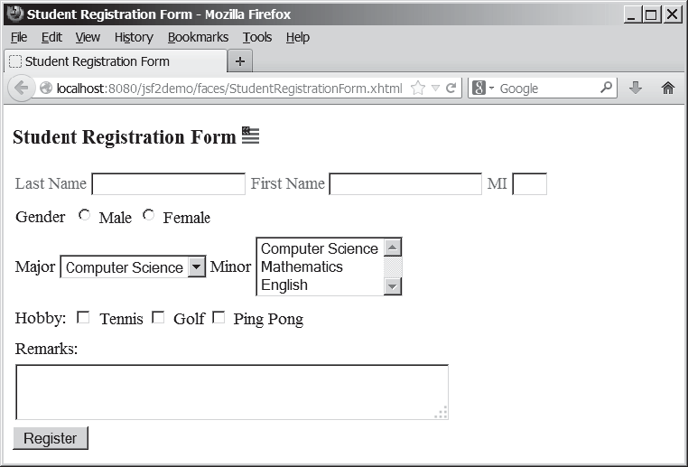
FIGuRE 39.11 A student registration form is displayed using JSF elements.

39-12 Chapter 39 JavaServer Faces



h:panelGrid h:outputLabel h:inputText

h:selectOneRadio f:selectItem

h:selectOneMenu


h:selectManyListBox

h:selectManyCheckbox

h:inputTextarea

h:commandButton
16
- <!-- Use h:panelGrid -->
- <h:panelGrid columns="6" style="color:green">
- <h:outputLabel value="Last Name"/>
- <h:inputText id="lastNameInputText" />
- <h:outputLabel value="First Name" />
- <h:inputText id="firstNameInputText" />
- <h:outputLabel value="MI" />
- <h:inputText id="miInputText" size="1" />
- </h:panelGrid>
26
- <!-- Use radio buttons -->
- <h:panelGrid columns="2">
- <h:outputLabel>Gender </h:outputLabel>
- <h:selectOneRadio id="genderSelectOneRadio">
- <f:selectItem itemValue="Male"
- itemLabel="Male"/>
- <f:selectItem itemValue="Female"
- itemLabel="Female"/>
- </h:selectOneRadio>
- </h:panelGrid>
37
- <!-- Use combo box and list -->
- <h:panelGrid columns="4">
- <h:outputLabel value="Major "/>
- <h:selectOneMenu id="majorSelectOneMenu">
- <f:selectItem itemValue="Computer Science"/>
- <f:selectItem itemValue="Mathematics"/>
- </h:selectOneMenu>
- <h:outputLabel value="Minor "/>
- <h:selectManyListbox id="minorSelectManyListbox">
- <f:selectItem itemValue="Computer Science"/>
- <f:selectItem itemValue="Mathematics"/>
- <f:selectItem itemValue="English"/>
- </h:selectManyListbox>
- </h:panelGrid>
52
- <!-- Use check boxes -->
- <h:panelGrid columns="4">
- <h:outputLabel value="Hobby: "/>
- <h:selectManyCheckbox id="hobbySelectManyCheckbox">
- <f:selectItem itemValue="Tennis"/>
- <f:selectItem itemValue="Golf"/>
- <f:selectItem itemValue="Ping Pong"/>
- </h:selectManyCheckbox>
- </h:panelGrid>
62
- <!-- Use text area -->
- <h:panelGrid columns="1">
- <h:outputLabel>Remarks:</h:outputLabel>
<h:inputTextarea id="remarksInputTextarea"
66
- style="width:400px; height:50px;" />
- </h:panelGrid>
69
- <!-- Use command button -->
- <h:commandButton value="Register" />
- </h:form>
- </h:body>
- </html>

  - JSF GUI Components 39-13

The tags with prefix f are in the JSF core tag library. Line 6
xmlns:f="http://xmlns.jcp.org/jsf/core">

locates the library for these tags.
The h:graphicImage tag displays an image in the file usIcon.gif (line 14). The file is located in the /resources/image folder. In JSF 2.0, all resources (image files, audio files, and CCS files) should be placed under the resources folder under the Web Pages node. You can create these folders as follows:
Step 1: Right-click the Web Pages node in the project pane to display a context menu and choose New, Folder to display the New Folder dialog box. (If Folder is not in the context menu, choose Other to locate it.)
Step 2: Enter resources as the Folder Name and click Finish to create the resources
folder, as shown in Figure 39.12.
Step 3: Right-click the resources node in the project pane to create the image folder under resources. You can now place usIcon.gif under the image folder.

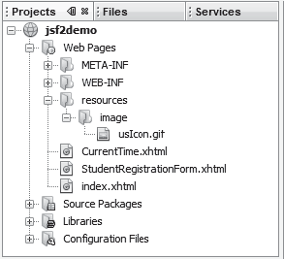
FIGuRE 39.12 The resources folder was created.
jsf core xmlns

h:graphicImage


JSF provides h:panelGrid and h:panelGroup elements to contain and layout subele- ments. h:panelGrid places the elements in a grid like the JavaFX GridPane. h:panelGrid places the elements in a grid with the specified number of columns. Lines 18–25 place six elements (labels and input texts) that are in an h:panelGrid. The columns attribute specifies that each row in the grid has 6 columns. The elements are placed into a row from left to right in the order they appear in the facelet. When a row is full, a new row is created to hold the elements. We used h:panelGrid in this example. You may replace it with h:panelGroup to see how the elements would be arranged.
You may use the style attribute with a JSF html tag to specify the CSS style for the ele- ment and its subelements. The style attribute in line 18 specifies color green for all elements in this h:panelGrid element.
The h:outputLabel element is for displaying a label (line 19). The value attribute speci- fies the label’s text.
The h:inputText element is for displaying a text input box for the user to enter a text (line 20). The id attribute is useful for other elements or the server program to reference this element.
The h:selectOneRadio element is for displaying a group of radio buttons (line 30). Each radio button is defined using an f:selectItem element (lines 31–34).

h:panelGrid

the style attribute

h:outputLabel h:inputText

h:selectOneRadio

39-14 Chapter 39 JavaServer Faces


h:selectOneMenu

h:selectManyListbox

h:selectManyCheckbox

h:selectTextarea h:commandButton

Check Point

Key Point


managed bean request scope property lastName
The h:selectOneMenu element is for displaying a combo box (line 41). Each item in the combo box is defined using an f:selectItem element (lines 42 and 43).
The h:selectManyListbox element is for displaying a list for the user to choose multiple items in a list (line 46). Each item in the list is defined using an f:selectItem element (lines 47–49).
The h:selectManyCheckbox element is for displaying a group of check boxes (line 56).
Each item in the check box is defined using an f:selectItem element (lines 57–59).
The h:selectTextarea element is for displaying a text area for multiple lines of input (line 66). The style attribute is used to specify the width and height of the text area (line 67). The h:commandButton element is for displaying a button (line 71). When the button is clicked, an action is performed. The default action is to request the same page from the server.
The next section shows how to process the form.
    - What is the name space for JSF tags with prefix h and prefix f?
    - Describe the use of the following tags?
h:form, h:panelGroup, h:panelGrid, h:inputText, h:outputText, h:inputTextArea, h:inputSecret, h:outputLabel, h:outputLink, h:selectOneMenu, h:selectOneRadio, h:selectBooleanCheckbox, h:selectOneListbox, h:selectManyListbox, h:selectItem, h:message, h:dataTable, h:columm, h:graphicImage

Processing the Form
Processing forms is a common task for Web programming. JSF provides tools for pro- cessing forms.
The preceding section introduced how to display a form using common JSF elements. This section shows how to obtain and process the input.
To obtain input from the form, simply bind each input element with a property in a man- aged bean. We now define a managed bean named registration as shown in Listing 39.5.

Listing 39.5 RegistrationJSFBean.java
1 package jsf2demo;
2
3 import javax.enterprise.context.RequestScoped;
4 import javax.inject.Named;
5
6 @Named(value = "registration") 7
@RequestScoped
- public class RegistrationJSFBean {
- private String lastName;
- private String firstName;
- private String mi;
- private String gender;
- private String major;
- private String[] minor;
- private String[] hobby;
- private String remarks; 17
- public RegistrationJSFBean() {
- }
20
- public String getLastName() {
- return lastName;
23 }




 |  |  | 39.4 | Processing the Form 39-15
24  25 | public void setLastName(String lastName) {
26 | this.lastName = lastName;
27 | }
28
29 | public String getFirstName() {
30 | return firstName;
31 | }
32
33 | public void setFirstName(String firstName) | {
34 | this.firstName = firstName;
35 | }
36
37 | public String getMi() {
38 | return mi;
39 | }
40
41 | public void setMi(String mi) {
42 | this.mi = mi;
43 | }
44
45 | public String getGender() {
46 | return gender;
47 | }
48
49 | public void setGender(String gender) {
50 | this.gender = gender;
51 | }
52
53 | public String getMajor() {
54 | return major;
55 | }
56
57 | public void setMajor(String major) {
58 | this.major = major;
59 | }
60
61 | public String[] getMinor() {
62 | return minor;
63 | }
64
65 | public void setMinor(String[] minor) {
66 | this.minor = minor;
67 | }
68
69 | public String[] getHobby() {
70 | return hobby;
71 | }
72
73 | public void setHobby(String[] hobby) {
74 | this.hobby = hobby;
75 | }
76
77 | public String getRemarks() {
78 | return remarks;
79 | }
80
81 | public void setRemarks(String remarks) {
82 | this.remarks = remarks;
83 | }

39-16 Chapter 39 JavaServer Faces


getResponse()

bean properties


jsf core namespace

bind lastName

bind firstName
84
- public String getResponse() {
- if (lastName == null)
- return ""; // Request has not been made
- else {
- String allMinor = "";
- for (String s: minor) {
- allMinor += s + " ";
92 }
93
- String allHobby = "";
- for (String s: hobby) {
- allHobby += s + " ";
97 }
98
- return "<p style=\"color:red\">You entered <br />" +
- "Last Name: " + lastName + "<br />" +
- "First Name: " + firstName + "<br />" +
- "MI: " + mi + "<br />" +
- "Gender: " + gender + "<br />" +
- "Major: " + major + "<br />" +
- "Minor: " + allMinor + "<br />" +
- "Hobby: " + allHobby + "<br />" +
- "Remarks: " + remarks + "</p>";
108 }
109 }
110 }

The RegistrationJSFBean class is a managed bean that defines the properties lastName, firstName, mi, gender, major, minor, and remarks, which will be bound to the elements in the JSF registration form.
The registration form can now be revised as shown in Listing 39.6. Figure 39.13 shows that new JSF page displays the user input upon clicking the Register button.

LISTING 39.6 ProcessStudentRegistrationForm.xhtml
  - <?xml version='1.0' encoding='UTF-8' ?>
  - <!DOCTYPE html PUBLIC "–//W3C//DTD XHTML 1.0 Transitional//EN"
  - "http://www.w3.org/TR/xhtml1/DTD/xhtml1-transitional.dtd">
  - <html xmlns="http://www.w3.org/1999/xhtml"
  - xmlns:h="http://xmlns.jcp.org/jsf/html"
  - xmlns:f="http://xmlns.jcp.org/jsf/core">
  - <h:head>
  - <title>Student Registration Form</title>
  - </h:head>
  - <h:body>
  - <h:form>
  - <!-- Use h:graphicImage -->
  - <h3>Student Registration Form
  - <h:graphicImage name="usIcon.gif" library="image"/>
15 </h3>
16
- <!-- Use h:panelGrid -->
- <h:panelGrid columns="6" style="color:green">
- <h:outputLabel value="Last Name"/>
- <h:inputText id="lastNameInputText"
- value="#{registration.lastName}"/>
- <h:outputLabel value="First Name" />
- <h:inputText id="firstNameInputText"
- value="#{registration.firstName}"/>

Processing the Form 39-17

- <h:outputLabel value="MI" />
- <h:inputText id="miInputText" size="1"
- value="#{registration.mi}"/>
- </h:panelGrid>
29
- <!-- Use radio buttons -->
- <h:panelGrid columns="2">
- <h:outputLabel>Gender </h:outputLabel>
- <h:selectOneRadio id="genderSelectOneRadio"
- value="#{registration.gender}">
- <f:selectItem itemValue="Male"
- itemLabel="Male"/>
- <f:selectItem itemValue="Female"
- itemLabel="Female"/>
- </h:selectOneRadio>
- </h:panelGrid>
41
- <!-- Use combo box and list -->
- <h:panelGrid columns="4">
- <h:outputLabel value="Major "/>
- <h:selectOneMenu id="majorSelectOneMenu"
- value="#{registration.major}">
- <f:selectItem itemValue="Computer Science"/>
- <f:selectItem itemValue="Mathematics"/>
- </h:selectOneMenu>
- <h:outputLabel value="Minor "/>
- <h:selectManyListbox id="minorSelectManyListbox"
- value="#{registration.minor}">
- <f:selectItem itemValue="Computer Science"/>
- <f:selectItem itemValue="Mathematics"/>
- <f:selectItem itemValue="English"/>
- </h:selectManyListbox>
- </h:panelGrid>
58
- <!-- Use check boxes -->
- <h:panelGrid columns="4">
- <h:outputLabel value="Hobby: "/>
- <h:selectManyCheckbox id="hobbySelectManyCheckbox"
- value="#{registration.hobby}">
- <f:selectItem itemValue="Tennis"/>
- <f:selectItem itemValue="Golf"/>
- <f:selectItem itemValue="Ping Pong"/>
- </h:selectManyCheckbox>
- </h:panelGrid>
69
- <!-- Use text area -->
- <h:panelGrid columns="1">
- <h:outputLabel>Remarks:</h:outputLabel>
- <h:inputTextarea id="remarksInputTextarea"
- style="width:400px; height:50px;"
- value="#{registration.remarks}"/>
- </h:panelGrid>
77
- <!-- Use command button -->
- <h:commandButton value="Register" />
- <br />
escape="false"

bind mi

bind gender

bind major

bind minor

bind hobby

bind remarks



- <h:outputText
82
- </h:form>
- </h:body>
- </html>
style="color:red" value="#{registration.response}" />

bind response

39-18 Chapter 39 JavaServer Faces

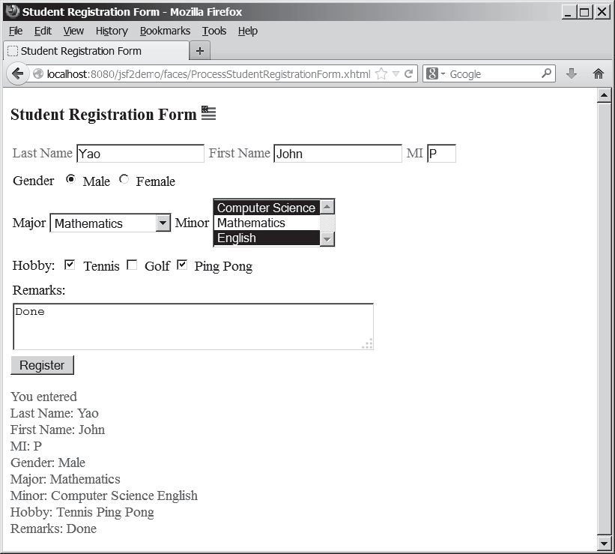
FIGuRE 39.13 The user input is collected and displayed after clicking the Register button.


binding input texts

binding radio buttons

binding combo box binding list box

binding check boxes

binding text area

binding response
The new JSF form in this listing binds the h:inputText element for last name, first name, and mi with the properties lastName, firstName, and mi in the managed bean (lines 21, 24, and 27). When the Register button is clicked, the page is sent to the server, which invokes the setter methods to set the properties in the managed bean.
The h:selectOneRadio element is bound to the gender property (line 34). Each radio button has an itemValue. The selected radio button’s itemValue is set to the gender prop- erty in the bean when the page is sent to the server.
The h:selectOneMenu element is bound to the major property (line 46). When the page is sent to the server, the selected item is returned as a string and is set to the major property. The h:selectManyListbox element is bound to the minor property (line 52). When the page is sent to the server, the selected items are returned as an array of strings and set to the
minor property.
The h:selectManyCheckbox element is bound to the hobby property (line 63). When the page is sent to the server, the checked boxes are returned as an array of itemValues and set to the hobby property.
The h:selectTextarea element is bound to the remarks property (line 75). When the page is sent to the server, the content in the text area is returned as a string and set to the remarks property.
The h:outputText element is bound to the response property (line 82). This is a read- only property in the bean. It is "" if lastName is null (lines 86 and 87 in Listing 39.5). When the page is returned to the client, the response property value is displayed in the output text element (line 82).

Case Study: Calculator 39-19

The h:outputText element’s escape attribute is set to false (line 81) to enable the contents to be displayed in HTML. By default, the escape attribute is true, which indicates the contents are considered regular text.
    - In the h:outputText tag, what is the escape attribute for?
    - Does every GUI component tag in JSF have the style attribute?

Case Study: Calculator
This section gives a case study on using GUI elements and processing forms.
This section uses JSF to develop a calculator to perform addition, subtraction, multiplication, and division, as shown in Figure 39.14.
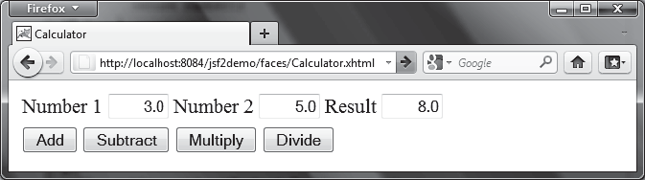
FIGuRE 39.14 This JSF application enables you to perform addition, subtraction, multiplication, and division.
escape attribute

Check Point

Key Point



Here are the steps to develop this project:
Step 1. Create a new managed bean named calculator with the request scope as shown in Listing 39.7, CalculatorJSFBean.java.
Step 2. Create a JSF facelet in Listing 39.8, Calculator.xhtml.

Listing 39.7 CalculatorJSFBean.java
1 package jsf2demo;
2
- import javax.inject.Named;
- import javax.enterprise.context.RequestScoped;
5
- @Named(value = "calculator")
- @RequestScoped
- public class CalculatorJSFBean {
- private Double number1;
- private Double number2;
- private Double result; 12
- public CalculatorJSFBean() {
- }
15
- public Double getNumber1() {
- return number1;
18 }
19
- public Double getNumber2() {
- return number2;
22 }
23

create managed bean

create JSF facelet

property number1 property number2 property result

39-20 Chapter 39 JavaServer Faces




add

subtract

divide

multiply

right align bind text input
- public Double getResult() {
- return result;
26 }
27
- public void setNumber1(Double number1) {
- this.number1 = number1;
30 }
31
- public void setNumber2(Double number2) {
- this.number2 = number2;
34 }
35
- public void setResult(Double result) {
- this.result = result;
38 }
39
- public void add() {
- result = number1 + number2;
42 }
43
- public void subtract() {
- result = number1 - number2;
46 }
47
- public void divide() {
- result = number1 / number2;
50 }
51
- public void multiply() {
- result = number1 * number2;
54 }
55 }

The managed bean has three properties number1, number2, and result (lines 9–38). The methods add(), subtract(), divide(), and multiply() add, subtract, multiply, and divide number1 with number2 and assigns the result to result (lines 40–54).
LISTING 39.8 Calculator.xhtml
  - <?xml version='1.0' encoding='UTF-8' ?>
  - <!DOCTYPE html PUBLIC "-//W3C//DTD XHTML 1.0 Transitional//EN"
  - "http://www.w3.org/TR/xhtml1/DTD/xhtml1-transitional.dtd">
  - <html xmlns="http://www.w3.org/1999/xhtml"
  - xmlns:h="http://xmlns.jcp.org/jsf/html">
  - <h:head>
  - <title>Calculator</title>
  - </h:head>
  - <h:body>
  - <h:form>
  - <h:panelGrid columns="6">
  - <h:outputLabel value="Number 1"/>
  - <h:inputText id="number1InputText" size ="4"
  - style="text-align: right"
  - value="#{calculator.number1}"/>
  - <h:outputLabel value="Number 2" />
  - <h:inputText id="number2InputText" size ="4"
  - style="text-align: right"
  - value="#{calculator.number2}"/>
  - <h:outputLabel value="Result" />
  - <h:inputText id="resultInputText" size ="4"

  - Session Tracking 39-21


- style="text-align: right"
- value="#{calculator.result}"/>
- </h:panelGrid>
25
- <h:panelGrid columns="4">
- <h:commandButton value="Add"
- action ="#{calculator.add}"/>
- <h:commandButton value="Subtract"
- action ="#{calculator.subtract}"/>
- <h:commandButton value="Multiply"
- action ="#{calculator.multiply}"/>
- <h:commandButton value="Divide"
- action ="#{calculator.divide}"/>
- </h:panelGrid>
- </h:form>
- </h:body>
- </html>

Three text input components along with their labels are placed in the grid panel (lines 11–24). Four button components are placed in the grid panel (lines 26–35).
The bean property number1 is bound to the text input for Number 1 (line 15). The CSS style text-align: right (line 14) specifies that the text is right aligned in the input box.
The action attribute for the Add button is set to the add method in the calculator bean (line 28). When the Add button is clicked, the add method in the bean is invoked to add number1 with number2 and assign the result to result. Since the result property is bound to the Result input text (line 23), the new result is now displayed in the text input field.



Session Tracking
You can create a managed bean at the application scope, session scope, view scope, or request scope.
JSF supports session tracking for managed beans at the application scope, session scope, view scope, and request scope. The scope is the lifetime of a bean. A request-scoped bean is alive in a single HTTP request. After the request is processed, the bean is no longer alive. A view-scoped bean lives as long as you are in the same JSF page. A session-scoped bean is alive for the entire Web session between a client and the server. An application-scoped bean lives as long as the Web application runs. In essence, a request-scoped bean is created once for a request; a view-scoped bean is created once for the view; a session-scoped bean is created once for the entire session; and an application-scoped bean is created once for the entire application. A managed bean with a session scope must be serializable because the system may need to free resources during and session and stores the bean to a file if the bean is not used for a while. When the bean is used again, the system will restore the bean to the memory.
Consider the following example that prompts the user to guess a number. When the page starts, the program randomly generates a number between 0 and 99. This number is stored in a bean. When the user enters a guess, the program checks the guess with the random number in the bean and tells the user whether the guess is too high, too low, or just right, as shown in Figure 39.15.
Here are the steps to develop this project:
Step 1. Create a new managed bean named guessNumber with the view scope as shown in Listing 39.9, GuessNumberJSFBean.java.
Step 2. Create a JSF facelet in Listing 39.10, GuessNumber.xhtml.

action

Key Point

scope
request scope view scope session scope application scope

create managed bean

create JSF facelet

39-22 Chapter 39 JavaServer Faces

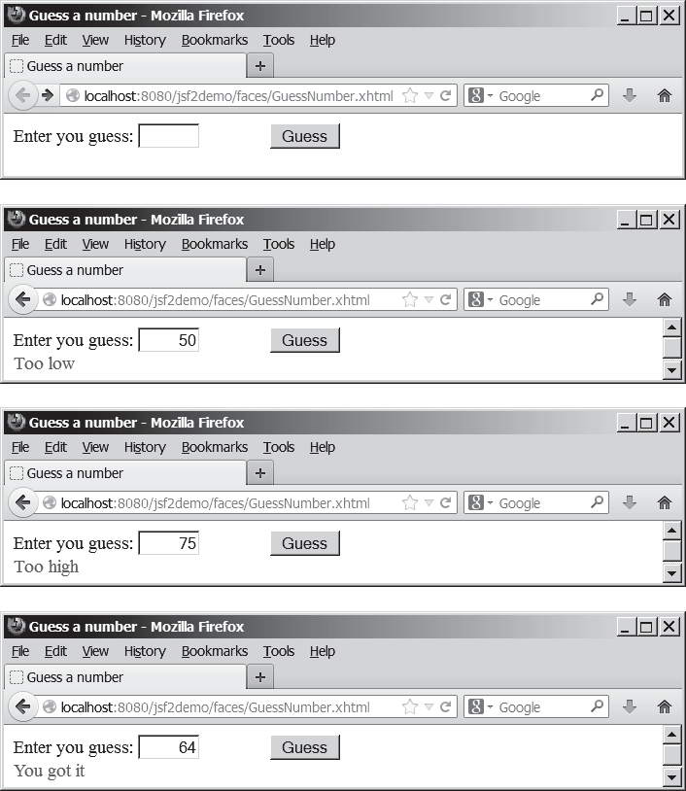



view scope

random number guess by user

create random number

getter method
FIGuRE 39.15 The user enters a guess and the program displays the result.

Listing 39.9 GuessNumberJSFBean.java
1 package jsf2demo;
2
- import javax.inject.Named;
- import javax.faces.view.ViewScoped;
5
- @Named(value = "guessNumber")
- @ViewScoped
- public class GuessNumberJSFBean {
- private int number;
- private String guessString; 11
- public GuessNumberJSFBean() {
- number = (int)(Math.random() * 100);
14 }
15
- public String getGuessString() {
- return guessString;
18 }

  - Session Tracking 39-23



19
- public void setGuessString(String guessString) {
- this.guessString = guessString;
22 }
23
- public String getResponse() {
- if (guessString == null)
- return ""; // No user input yet 27
- int guess = Integer.parseInt(guessString);
- if (guess < number)
- return "Too low";
- else if (guess == number)
- return "You got it";
- else
- return "Too high";
35 }
36 }
The managed bean uses the @ViewScope annotation (line 7) to set up the view scope for the bean. The view scope is most appropriate for this project. The bean is alive as long as the view is not changed. The bean is created when the page is displayed for the first time. A random number between 0 and 99 is assigned to number (line 13) when the bean is created. This number will not change as long as the bean is alive in the same view.
The getResponse method converts guessString from the user input to an integer (line 28) and determines if the guess is too low (line 30), too high (line 34), and just right (line 32).
LISTING 39.10 GuessNumber.xhtml
  - <?xml version='1.0' encoding='UTF-8' ?>
  - <!DOCTYPE html PUBLIC "-//W3C//DTD XHTML 1.0 Transitional//EN"
  - "http://www.w3.org/TR/xhtml1/DTD/xhtml1-transitional.dtd">
  - <html xmlns="http://www.w3.org/1999/xhtml"
  - xmlns:h="http://xmlns.jcp.org/jsf/html">
  - <h:head>
  - <title>Guess a number</title>
  - </h:head>
  - <h:body>
  - <h:form>
  - <h:outputLabel value="Enter you guess: "/>
  - <h:inputText style="text-align: right; width: 50px"
  - id="guessInputText"
  - value="#{guessNumber.guessString}"/>
  - <h:commandButton style="margin-left: 60px" value="Guess" />
  - <br />
style="color: red"
  - <h:outputText
  - value="#{guessNumber.response}" />
  - </h:form>
  - </h:body>
  - </html>
The bean property guessString is bound to the text input (line 14). The CSS style text- align: right (line 13) specifies that the text is right aligned in the input box.
The CSS style margin-left: 60px (line 15) specifies that the command button has a left margin of 60 pixels.
The bean property response is bound to the text output (line 18). The CSS style color: red (line 17) specifies that the text is displayed in red in the output box.
The project uses the view scope. What happens if the scope is changed to the request scope? Every time the page is refreshed, JSF creates a new bean with a new random number. What happens if the scope is changed to the session scope? The bean will be alive as long as the

setter method

get response

check guess

bind text input

bind text output

scope

39-24 Chapter 39 JavaServer Faces
browser is alive. What happens if the scope is changed to the application scope? The bean will be created once when the application is launched from the server. So every client will use the same random number.

Check Point

Key Point


    - What is a scope? What are the available scopes in JSF? Explain request scope, view scope, session scope, and application scope. How do you set a request scope, view scope, session scope, and application scope in a managed bean?
    - What happens if the bean scope in Listing 39.9 GuessNumberJSFBean.java is changed to request?
    - What happens if the bean scope in Listing 39.9 GuessNumberJSFBean.java is changed to session?
    - What happens if the bean scope in Listing 39.9 GuessNumberJSFBean.java is changed to application?

Validating Input
JSF provides tools for validating user input.
In the preceding GuessNumber page, an error would occur if you entered a noninteger in the input box before clicking the Guess button. One way to fix the problem is to check the text field before processing any event. But a better way is to user the validators. You can use the standard validator tags in the JSF Core Tag Library or create custom validators. Table 39.2 lists some JSF input validator tags.

TABLE 39.2 JSF Input Validator Tags

JSF Tag Description

f:validateLength validates the length of the input.
f:validateDoubleRange validates whether numeric input falls within acceptable range of double
values.
f:validateLongRange validates whether numeric input falls within acceptable range of long
values.
f:validateRequired validates whether a field is not empty.
f:validateRegex validates whether the input matches a regualar expression.
f:validateBean invokes a custom method in a bean to perform custom validation.


Consider the following example that displays a form for collecting user input as shown in Figure 39.16. All text fields in the form must be filled. If not, error messages are displayed. The SSN must be formatted correctly. If not, an error is displayed. If all input are correct, clicking Submit displays the result in an output text, as shown in Figure 39.17.
Here are the steps to create this project.
Step 1. Create a new page in Listing 39.11, ValidateForm.xhtml.
Step 2. Create a new managed bean named validateForm, as shown in Listing 39.12.

LISTING 39.11 ValidateForm.xhtml
- <?xml version='1.0' encoding='UTF-8' ?>
- <!DOCTYPE html PUBLIC "-//W3C//DTD XHTML 1.0 Transitional//EN"
- "http://www.w3.org/TR/xhtml1/DTD/xhtml1-transitional.dtd">
- <html xmlns="http://www.w3.org/1999/xhtml"
- xmlns:h="http://xmlns.jcp.org/jsf/html"
- xmlns:f="http://xmlns.jcp.org/jsf/core">
- <h:head>


  - Validating Input 39-25

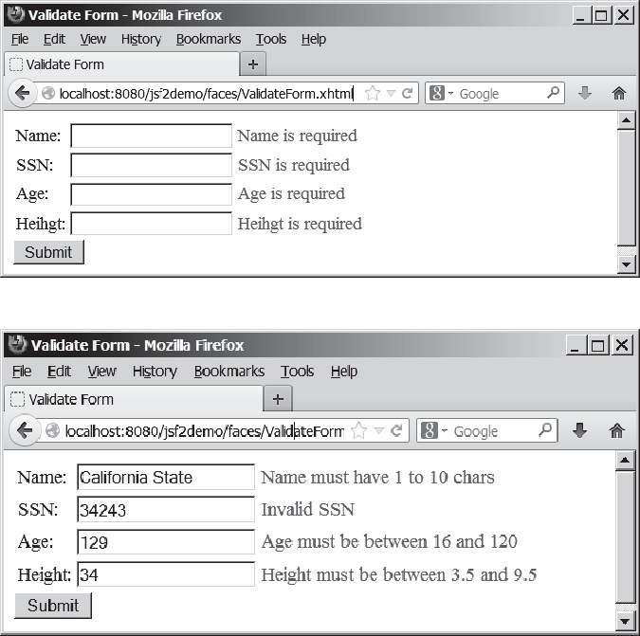
(a) The required messages are displayed if input is required, but empty.
(b) Error messages are displayed if input is incorrect.
FIGuRE 39.16 The input fields are validated.

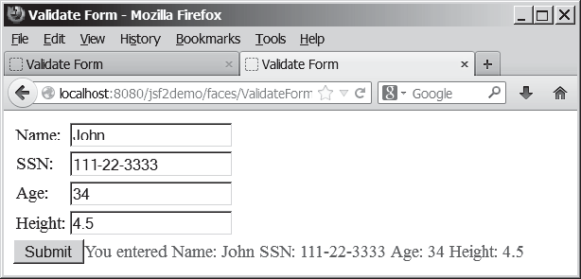
FIGuRE 39.17 The correct input values are displayed.

- <title>Validate Form</title>
- </h:head>
- <h:body>
- <h:form>
- <h:panelGrid columns="3">
- <h:outputLabel value="Name:"/>

39-26 Chapter 39 JavaServer Faces

required input
- <h:inputText id="nameInputText"
required="true"

required message 15
validator message 16
17
validate length 18
requiredMessage="Name is required" validatorMessage="Name must have 1 to 10 chars" value="#{validateForm.name}">
<f:validateLength minimum="1" maximum="10" />


message element

validate regex

validate integer range



validate double range

required attribute
requiredMessage

validatorMessage f:validateLength

h:message

f:validateRegex f:validateLongRange f:validateDoubleRange
- </h:inputText>
- <h:message for="nameInputText" style="color:red"/> 21
- <h:outputLabel value="SSN:" />
- <h:inputText id="ssnInputText" required="true"
- requiredMessage="SSN is required"
- validatorMessage="Invalid SSN"
- value="#{validateForm.ssn}">
- <f:validateRegex pattern="[\d]{3}–[\d]{2}–[\d]{4}"/>
- </h:inputText>
- <h:message for="ssnInputText" style="color:red"/> 30
- <h:outputLabel value="Age:" />
- <h:inputText id="ageInputText" required="true"
- requiredMessage="Age is required"
- validatorMessage="Age must be between 16 and 120"
- value="#{validateForm.ageString}">
- <f:validateLongRange minimum="16" maximum="120"/>
- </h:inputText>
- <h:message for="ageInputText" style="color:red"/> 39
- <h:outputLabel value="Height:" />
- <h:inputText id="heightInputText" required="true"
- requiredMessage="Height is required"
- validatorMessage="Height must be between 3.5 and 9.5"
- value="#{validateForm.heightString}">
- <f:validateDoubleRange minimum="3.5" maximum="9.5"/>
- </h:inputText>
- <h:message for="heightInputText" style="color:red"/>
- </h:panelGrid>
49
50 <h:commandButton value="Submit" /> 51
- <h:outputText style="color:red"
- value="#{validateForm.response}" />
- </h:form>
- </h:body>
- </html>

For each input text field, set its required attribute true (lines 14, 23, 32, and 41) to indicate that an input value is required for the field. When a required input field is empty, the requiredMessage is displayed (lines 15, 24, 33, and 42).
The validatorMessage attribute specifies a message to be displayed if the input field is invalid (line 16). The f:validateLength tag specifies the minimum or maximum length of the input (line 18). JSF will determine whether the input length is valid.
The h:message element displays the validatorMessage if the input is invalid. The ele- ment’s for attribute specifies the id of the element for which the message will be displayed (line 20).
The f:validateRegex tag specifies a regular expression for validating the input (line 27). For information on regular expression, see Appendix H.
The f:validateLongRange tag specifies a range for an integer input using the minimum
and maximum attributes (line 45). In this project, a valid age value is between 16 and 120.
The f:validateDoubleRange tag specifies a range for a double input using the minimum
and maximum attributes (line 36). In this project, a valid height value is between 3.5 and 9.5.




Listing 39.12 ValidateFormJSFBean.java
1 package jsf2demo;
2
- import javax.enterprise.context.RequestScoped;
- import javax.inject.Named;
5
- @Named(value = "validateForm")
- @RequestScoped
- public class ValidateFormJSFBean {
- private String name;
- private String ssn;
- private String ageString;
- private String heightString; 13
- public String getName() {
- return name;
16 }
17
- public void setName(String name) {
- this.name = name;
20 }
21
  - public String getSsn() {
  - return ssn;
24 }
25
- public void setSsn(String ssn) {
- this.ssn = ssn;
28 }
29
- public String getAgeString() {
- return ageString;
32 }
33
- public void setAgeString(String ageString) {
- this.ageString = ageString;
36 }
37
- public String getHeightString() {
- return heightString;
40 }
41
- public void setHeightString(String heightString) {
- this.heightString = heightString;
44 }
45
- public String getResponse() {
- if (name == null || ssn == null || ageString == null
- || heightString == null) {
- return "";
50 }
- else {
- return "You entered " +
- " Name: " + name +
- " SSN: " + ssn +
- " Age: " + ageString +
- " Height: " + heightString;
57 }
58 }
59 }
  - Validating Input 39-27

some input not set

39-28 Chapter 39 JavaServer Faces

Managed bean JSF page

style sheet

Check Point

Key Point
If an input is invalid, its value is not set to the bean. So only when all input are correct, the
getResponse() method will return all input values (lines 46–58).
    - Write a tag that validates an input text with minimal length of 2 and maximum 12.
    - Write a tag that validates an input text for SSN using a regular expression.
    - Write a tag that validates an input text for a double value with minimal 4.5 and maximum 19.9.
    - Write a tag that validates an input text for an integer value with minimal 4 and maximum 20.
    - Write a tag that makes an input text required.

Binding Database with Facelets
You can bind a database in JSF applications.
Often you need to access a database from a Web page. This section gives examples of building Web applications using databases.
Consider the following example that lets the user choose a course, as shown in Figure 39.18. After a course is selected in the combo box, the students enrolled in the course are displayed in the table, as shown in Figure 39.19. In this example, all the course titles in the Course table are bound to the combo box and the query result for the students enrolled in the course is bound to the table.
Here are the steps to create this project:
Step 1. Create a managed bean named courseName with application scope, as shown in Listing 39.13.
Step 2. Create a JSF in Listing 39.14, DisplayStudent.xhtml.
Step 3. Create a cascading style sheet for formatting the table as follows:
Step 3.1. Right-click the resources node to choose New, Others to display the New File dialog box, as shown in Figure 39.20.




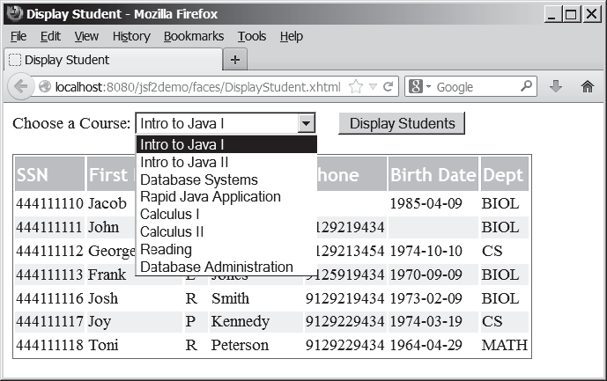
FIGuRE 39.18 You need to choose a course and display the students enrolled in the course.



Binding Database with Facelets 39-29
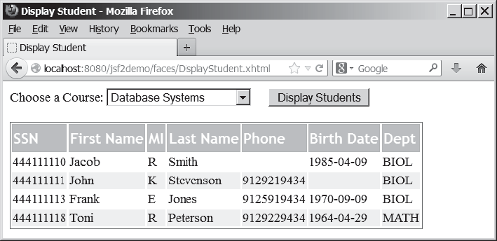
FIGuRE 39.19 The table displays the students enrolled in the course.

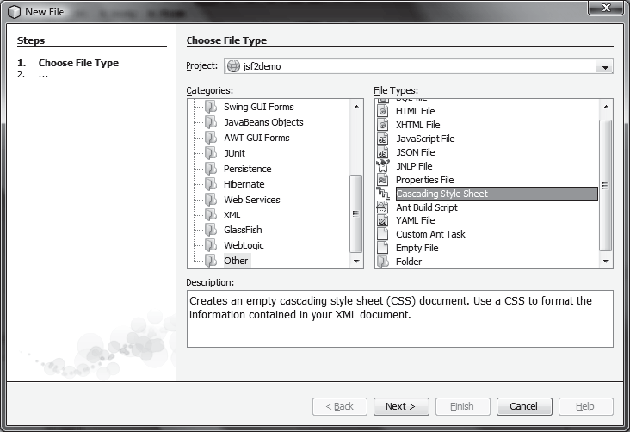
FIGuRE 39.20 You can create CSS files for Web project in NetBenas.

Step 3.2. Choose Other in the Categories section and Cascading Style Sheet in the File Types section to display the New Cascading Style Sheet dialog box, as shown in Figure 39.21.
Step 3.3. Enter tablestyle as the File Name and click Finish to create tablestyle.css under the resources node.
Step 3.4. Define the CSS style as shown in Listing 39.15.

39-30 Chapter 39 JavaServer Faces
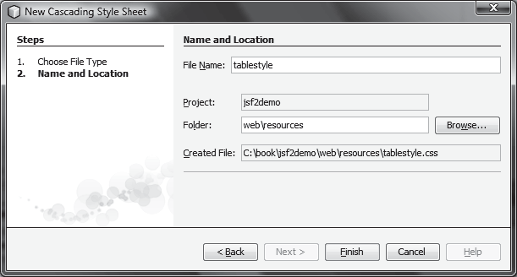





application scope

initialize JDBC

connect to database

get course titles execute SQL
FIGuRE 39.21 The New Cascading Style Sheet dialog box creates a new style sheet file.

Listing 39.13 CourseNameJSFBean.java
1 package jsf2demo;
2
- import java.sql.*;
- import java.util.ArrayList;
- import javax.enterprise.context.ApplicationScoped;
- import javax.inject.Named;
7
8 @Named(value = "courseName") 9
@ApplicationScoped
- public class CourseNameJSFBean {
- private PreparedStatement studentStatement = null;
- private String choice; // Selected course
- private String[] titles; // Course titles 14
- /** Creates a new instance of CourseName */
- public CourseNameJSFBean() {
- initializeJdbc();
18 }
19
- /** Initialize database connection */
- private void initializeJdbc() {
- try {
- Class.forName("com.mysql.jdbc.Driver");
- System.out.println("Driver loaded");
25
26 // Connect to the sample database
27 Connection connection = DriverManager.getConnection(
28 "jdbc:mysql://localhost/javabook", "scott", "tiger"); 29
30 // Get course titles 31
PreparedStatement statement = connection.prepareStatement(
32 "select title from course"); 33
34 ResultSet resultSet = statement.executeQuery(); 35
- // Store resultSet into array titles
- ArrayList<String> list = new ArrayList<>();

Binding Database with Facelets 39-31

43
38 |  | while (resultSet.next()) {
39 |  | list.add(resultSet.getString(1));
40 |  | }
41 |  | titles = new String[list.size()]; // Array for titles | titles array
42 |  | list.toArray(titles); // Copy strings from list to array
44 |  | // Define a SQL statement for getting students
45 |  | studentStatement = connection.prepareStatement(
46 |  | "select Student.ssn, "
47 |  | + "student.firstName, Student.mi, Student.lastName, "
48 |  | + "Student.phone, Student.birthDate, Student.street, "
49 |  | + "Student.zipCode, Student.deptId "
50 |  | + "from Student, Enrollment, Course "
51 |  | + "where Course.title = ? "
52 |  | + "and Student.ssn = Enrollment.ssn "
53 |  | + "and Enrollment.courseId = Course.courseId;");
54 |  | }
55 |  | catch (Exception ex) {
56 |  | ex.printStackTrace();
57 |  | }
58 | }
59



- public String[] getTitles() {
- return titles;
62 }
63
- public String getChoice() {
- return choice;
66 }
67
- public void setChoice(String choice) {
- this.choice = choice;
70 }
71
- public ResultSet getStudents() throws SQLException {
- if (choice == null) {
- if (titles.length == 0)
- return null;
- else
- studentStatement.setString(1, titles[0]);
78 }
- else {
- studentStatement.setString(1, choice); // Set course title
81 }
82
- // Get students for the specified course
- return studentStatement.executeQuery();
85 }
86 }

We use the same MySQL database javabook created in Chapter 34, “Java Database Program- ming.” The scope for this managed bean is application. The bean is created when the project is launched from the server. The initializeJdbc method loads the JDBC driver for MySQL (lines 23 and 24), connects to the MySQL database (lines 27 and 28), creates statement for obtaining course titles (lines 31 and 32), and creates a statement for obtaining the student infor- mation for the specified course (lines 45–53). Lines 31–42 execute the statement for obtaining course titles and store them in array titles.
The getStudents() method returns a ResultSet that consists of all students enrolled in
the specified course (lines 72–85). The choice for the title is set in the statement to obtain the

get students

set a default course

set a course

return students

39-32 Chapter 39 JavaServer Faces
student for the specified title (line 80). If choice is null, the first title in the titles array is set in the statement (line 77). If no titles in the course, getStudents() returns null (line 75).



add MySQL in the Libraries node

style sheet

bind choice titles

display button



bind result set rowClasses headerClass styleClass

ssn column

firstName column

mi column

lastName column

phone column
TIP
In order to use the MySQL database from this project, you have to add the MySQL JDBC driver from the Libraries node in the Project pane in NetBeans.

Listing 39.14 DisplayStudent.xhtml
- <?xml version='1.0' encoding='UTF-8' ?>
- <!DOCTYPE html PUBLIC "-//W3C//DTD XHTML 1.0 Transitional//EN"
- "http://www.w3.org/TR/xhtml1/DTD/xhtml1-transitional.dtd">
- <html xmlns="http://www.w3.org/1999/xhtml"
- xmlns:h="http://xmlns.jcp.org/jsf/html"
- xmlns:f="http://xmlns.jcp.org/jsf/core">
- <h:head>
- <title>Display Student</title>
- <h:outputStylesheet name="tablestyle.css"/>
- </h:head>
- <h:body>
- <h:form>
- <h:outputLabel value="Choose a Course: " />
- <h:selectOneMenu value="#{courseName.choice}">
- <f:selectItems value="#{courseName.titles}" />
- </h:selectOneMenu>
17
- <h:commandButton style="margin-left: 20px"
- value="Display Students" /> 20
21 <br /> <br />
- <h:dataTable value="#{courseName.students}" var="student"
- rowClasses="oddTableRow, evenTableRow"
- headerClass="tableHeader"
- styleClass="table">
- <h:column>
- <f:facet name="header">SSN</f:facet>
- #{student.ssn}
- </h:column>
30
- <h:column>
- <f:facet name="header">First Name</f:facet>
- #{student.firstName}
- </h:column>
35
- <h:column>
- <f:facet name="header">MI</f:facet>
- #{student.mi}
- </h:column>
40
- <h:column>
- <f:facet name="header">Last Name</f:facet>
- #{student.lastName}
- </h:column>
45
- <h:column>
- <f:facet name="header">Phone</f:facet>
- #{student.phone}
- </h:column>
50
- <h:column>

39.8 Binding Database with Facelets 39-33



- <f:facet name="header">Birth Date</f:facet>
- #{student.birthDate}
- </h:column>
55
- <h:column>
- <f:facet name="header">Dept</f:facet>
- #{student.deptId}
- </h:column>
- </h:dataTable>
- </h:form>
- </h:body>
- </html>

Line 9 specifies that the style sheet tablestyle.css created in Step 3 is used in this XMTHL file. The rowClasses = "oddTableRow, evenTableRow" attribute specifies the style applied to the rows alternately using oddTableRow and evenTableRow (line 23). The header- Classes = "tableHeader" attribute specifies that the tableHeader class is used for header style (line 24). The styleClasses = "table" attribute specifies that the table class is used for the style of all other elements in the table (line 25).
Line 14 binds the choice property in the courseName bean with the combo box. The selection values in the combo box are bound with the titles array property (line 15).
Line 22 binds the table value with a database result set using the attribute value="#{courseName.students}". The var="student" attribute associates a row in the result set with student. Lines 26–59 specify the column values using student.ssn (line 28), student.firstName (line 33), student.mi (line 38), student.lastName (line 33), stu- dent.phone (line 48), student.birthDate (line 53), and student.deptId (line 58).

LISTING 39.15 tablestyle.css
- /* Style for table */
- .tableHeader {
- font-family:"Trebuchet MS", Arial, Helvetica, sans-serif;
- border-collapse:collapse;
- font-size:1.1em;
- text-align:left;
- padding-top:5px;
- padding-bottom:4px;
- background-color:#A7C942;
- color:white;
- border:1px solid #98bf21;
12 }
13
- .oddTableRow {
- border:1px solid #98bf21;
16 }
17
- .evenTableRow {
- background-color: #eeeeee;
- font-size:1em;
21
22 padding:3px 7px 2px 7px; 23
24 color:#000000;
- background-color:#EAF2D3;
26 }
27
- .table {
- border:1px solid green;
30 }

birthDate column

deptId column

tableHeader

oddTableRow

evenTableRow

table

39-34 Chapter 39 JavaServer Faces
The style sheet file defines the style classes tableHeader (line 2) for table header style, oddTableRow for odd table rows (line 14), evenTableRow for even table rows (line 18), and table for all other table elements (line 28).

39.9 Opening New JSF Pages

Key Point
You can open new JSF pages from the current JSF pages.
All the examples you have seen so far use only one JSF page in a project. Suppose you want to register student information to the database. The application first displays the page as shown in Figures 39.22 to collect student information. After the user enters the information and clicks the Submit button, a new page is displayed to ask the user to confirm the input, as shown in Figure 39.23. If the user clicks the Confirm button, the data are stored into the database and the status page is displayed, as shown in Figure 39.24. If the user clicks the Go Back button, it goes back to the first page.

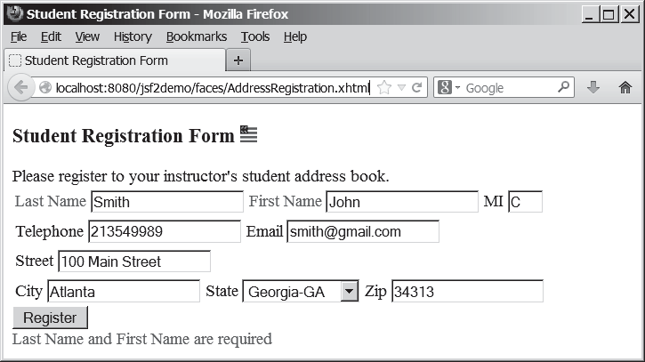
FIGuRE 39.22 This page lets the user enter input.



jsf core namespace
For this project, you need to create three JSF pages named AddressRegistration.xhtml, ConfirmAddress.xhtml, and AddressStoredStatus.xhtml in Listings 39.16–39.18. The project starts with AddressRegistration.xhtml. When clicking the Submit button, the action for the button returns “ConfirmAddress” if the last name and first name are not empty, which causes ConfirmAddress.xhtml to be displayed. When clicking the Confirm button, the status page AddressStoredStatus is displayed. When clicking the Go Back button, the first page Address- Registration is now displayed.
Listing 39.16 AddressRegistration.xhtml
- <?xml version='1.0' encoding='UTF-8' ?>
- <!DOCTYPE html PUBLIC "-//W3C//DTD XHTML 1.0 Transitional//EN"
- "http://www.w3.org/TR/xhtml1/DTD/xhtml1-transitional.dtd">
- <html xmlns="http://www.w3.org/1999/xhtml"
- xmlns:h="http://xmlns.jcp.org/jsf/html"
- xmlns:f="http://xmlns.jcp.org/jsf/core">
- <h:head>
- <title>Student Registration Form</title>

Opening New JSF Pages 39-35
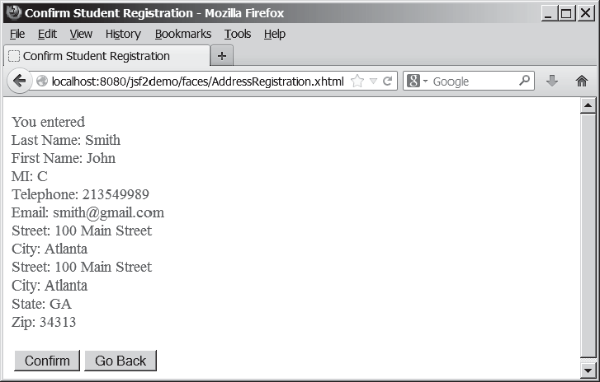
FIGuRE 39.23 This page lets the user confirm the input.

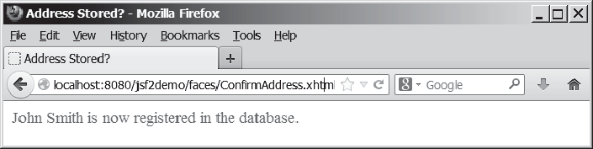
FIGuRE 39.24 This page displays the status of the user input.


- </h:head>
- <h:body>
- <h:form>
- <!-- Use h:graphicImage -->
- <h3>Student Registration Form
- <h:graphicImage name="usIcon.gif" library="image"/>
15 </h3>
16
- Please register to your instructor's student address book.
- <!-- Use h:panelGrid -->
- <h:panelGrid columns="6">
- <h:outputLabel value="Last Name" style="color:red"/>
- <h:inputText id="lastNameInputText"
- value="#{addressRegistration.lastName}"/>
- <h:outputLabel value="First Name" style="color:red"/>
- <h:inputText id="firstNameInputText"
- value="#{addressRegistration.firstName}"/>
- <h:outputLabel value="MI" />
- <h:inputText id="miInputText" size="1"
- value="#{addressRegistration.mi}"/>
- </h:panelGrid>
30

bind lastName

bind firstName

bind mi

39-36 Chapter 39 JavaServer Faces




bind telephone

bind email

bind street

bind city

bind state

bind zip

process register

process confirm

go to AddressRegistration page
- <h:panelGrid columns="4">
- <h:outputLabel value="Telephone"/>
- <h:inputText id="telephoneInputText"
- value="#{addressRegistration.telephone}"/>
- <h:outputLabel value="Email"/>
- <h:inputText id="emailInputText"
- value="#{addressRegistration.email}"/>
- </h:panelGrid>
39
- <h:panelGrid columns="4">
- <h:outputLabel value="Street"/>
- <h:inputText id="streetInputText"
- value="#{addressRegistration.street}"/>
- </h:panelGrid>
45
- <h:panelGrid columns="6">
- <h:outputLabel value="City"/>
- <h:inputText id="cityInputText"
- value="#{addressRegistration.city}"/>
- <h:outputLabel value="State"/>
- <h:selectOneMenu id="stateSelectOneMenu"
- value="#{addressRegistration.state}">
- <f:selectItem itemLabel="Georgia-GA" itemValue="GA" />
- <f:selectItem itemLabel="Oklahoma-OK" itemValue="OK" />
- <f:selectItem itemLabel="Indiana-IN" itemValue="IN"/>
- </h:selectOneMenu>
- <h:outputLabel value="Zip"/>
- <h:inputText id="zipInputText"
- value="#{addressRegistration.zip}"/>
- </h:panelGrid>
61
- <!-- Use command button -->
- <h:commandButton value="Register"
- action="#{addressRegistration.processSubmit()}"/>
65 <br />
- <h:outputText escape="false" style="color:red"
- value="#{addressRegistration.requiredFields}" />
- </h:form>
- </h:body>
- </html>

Listing 39.17 ConfirmAddress.xhtml
- <?xml version='1.0' encoding='UTF-8' ?>
- <!DOCTYPE html PUBLIC "-//W3C//DTD XHTML 1.0 Transitional//EN"
- "http://www.w3.org/TR/xhtml1/DTD/xhtml1-transitional.dtd">
- <html xmlns="http://www.w3.org/1999/xhtml"
- xmlns:h="http://xmlns.jcp.org/jsf/html">
- <h:head>
- <title>Confirm Student Registration</title>
- </h:head>
- <h:body>
- <h:form>
- <h:outputText escape="false" style="color:red"
- value="#{registration1.input}" />
- <h:panelGrid columns="2">
- <h:commandButton value="Confirm"
- action = "#{registration1.storeStudent()}"/>
- <h:commandButton value="Go Back"
- action = "AddressRegistration"/>

Opening New JSF Pages 39-37



- </h:panelGrid>
- </h:form>
- </h:body>
- </html>

Listing 39.18 AddressStoredStatus.xhtml
- <?xml version='1.0' encoding='UTF-8' ?>
- <!DOCTYPE html PUBLIC "-//W3C//DTD XHTML 1.0 Transitional//EN"
- "http://www.w3.org/TR/xhtml1/DTD/xhtml1-transitional.dtd">
- <html xmlns="http://www.w3.org/1999/xhtml"
- xmlns:h="http://xmlns.jcp.org/jsf/html">
- <h:head>
- <title>Address Stored?</title>
- </h:head>
- <h:body>
- <h:form>
- <h:outputText escape="false" style="color:green"
- value="#{registration1.status}" />
- </h:form>
- </h:body>
- </html>

Listing 39.19 AddressRegistrationJSFBean.java
1 package jsf2demo;
2
- import javax.inject.Named;
- import javax.enterprise.context.SessionScoped;
- import java.sql.*;
- import java.io.Serializable;
7
- @Named(value = "addressRegistration")
- @SessionScoped
- public class AddressRegistrationJSFBean implements Serializable {
- private String lastName;
- private String firstName;
- private String mi;
- private String telephone;
- private String email;
- private String street;
- private String city;
- private String state;
- private String zip;
- private String status = "Nothing stored";
- // Use a prepared statement to store a student into the database
- private PreparedStatement pstmt; 23
- public AddressRegistrationJSFBean() {
- initializeJdbc();
26 }
27
- public String getLastName() {
- return lastName;
30 }
31
- public void setLastName(String lastName) {
- this.lastName = lastName;
34 }
35

display status

managed bean session scope

property lastName

initialize database



39-38 Chapter 39 JavaServer Faces

36 | public String getFirstName() {
37 | return firstName;
38 | }
39
40 | public void setFirstName(String firstName) | {
41 | this.firstName = firstName;
42 | }
43
44 | public String getMi() {
45 | return mi;
46 | }
47
48 | public void setMi(String mi) {
49 | this.mi = mi;
50 | }
51
52 | public String getTelephone() {
53 | return telephone;
54 | }
55
56 | public void setTelephone(String telephone) | {
57 | this.telephone = telephone;
58 | }
59
60 | public String getEmail() {
61 | return email;
62 | }
63
64 | public void setEmail(String email) {
65 | this.email = email;
66 | }
67
68 | public String getStreet() {
69 | return street;
70 | }
71
72 | public void setStreet(String street) {
73 | this.street = street;
74 | }
75
76 | public String getCity() {
77 | return city;
78 | }
79
80 | public void setCity(String city) {
81 | this.city = city;
82 | }
83
84 | public String getState() {
85 | return state;
86 | }
87
88 | public void setState(String state) {
89 | this.state = state;
90 | }
91
92 | public String getZip() {
93 | return zip;
94 | }
95
96 | public void setZip(String zip) {



  - Opening New JSF Pages 39-39

97 |  | this.zip = zip;
98 | }
99
100 | private boolean isRquiredFieldsFilled() {
101 | return !(lastName == null || firstName == null
102 | || lastName.trim().length() == 0
103 | || firstName.trim().length() == 0);
104 | }
105
106 | public String processSubmit() {
107 | if (isRquiredFieldsFilled())
108 | return "ConfirmAddress"; |  |  |  |  | go to a new page
109 | else
110 | return "";
111 | }
112
113 | public String getRequiredFields() {
114 | if (isRquiredFieldsFilled()) |  |  |  |  | check required fields
115 |  | return | "";
116 |  | else
117 |  | return | "Last Name and First Name | are | required";
118 | }
119
120 | public String getInput() { |  |  |  |  | get input
121 | return "<p style=\"color:red\">You entered <br />"
122 | + "Last Name: " + lastName + "<br />"
123 | + "First Name: " + firstName + "<br />"
124 | + "MI: " + mi + "<br />"
125 | + "Telephone: " + telephone + "<br />"
126 | + "Email: " + email + "<br />"
127 | + "Street: " + street + "<br />"
128 | + "City: " + city + "<br />"
129 | + "Street: " + street + "<br />"
130 | + "City: " + city + "<br />"
131 | + "State: " + state + "<br />"
132 | + "Zip: " + zip + "</p>";
133 | }
134
135 | /** Initialize database connection */
136 | private void initializeJdbc() {
137 | try {
138 | // Explicitly load a MySQL driver
139 | Class.forName("com.mysql.jdbc.Driver");
140 | System.out.println("Driver loaded");
141
142 | // Establish a connection
143 | Connection conn = DriverManager.getConnection(
144 | "jdbc:mysql://localhost/javabook", "scott", "tiger");
145
146 | // Create a Statement
147 | pstmt = conn.prepareStatement("insert into Address (lastName,"
148 | + " firstName, mi, telephone, email, street, city, "
149 | + "state, zip) values (?, ?, ?, ?, ?, ?, ?, ?, ?)");
150 | }
151 | catch (Exception ex) {
152 | System.out.println(ex);
153 | }
154 | }
155
156 | /** Store an address to the database */
157 | public String storeStudent() { |  |  |  |  | store address

39-40 Chapter 39 JavaServer Faces



update status

go to a new page


- try {
- pstmt.setString(1, lastName);
- pstmt.setString(2, firstName);
- pstmt.setString(3, mi);
- pstmt.setString(4, telephone);
- pstmt.setString(5, email);
- pstmt.setString(6, street);
- pstmt.setString(7, city);
- pstmt.setString(8, state);
- pstmt.setString(9, zip);
168 | pstmt.executeUpdate();
169 | status = firstName + " " + lastName
170 | + " is now registered in the database.";
171 | }
172 | catch (Exception ex) {
173 | status = ex.getMessage();
174 |  |  | }
175
176 |  |  | return "AddressStoredStatus";
177 | }
178
179 |  | public String getStatus() {
180 |  | return status;
181 |  | }
182 | }
A session-scoped managed bean must implement the java.io.Serializable interface. So, the AddressRegistration class is defined as a subtype of java.io.Serializable. The action for the Register button in the AddressRegistration JSF page is process- Submit() (line 64 in AddressRegistration.xhtml). This method checks if last name and first name are not empty (lines 106–111 in AddressRegistrationJSFBean.java). If so, it returns a
string "ConfirmAddress", which causes the ConfirmAddress JSF page to be displayed. The ConfirmAddress JSF page displays the data entered from the user (line 12 in Confir-
mAddress.xhtml). The getInput() method (lines 120–133 in AddressRegistrationJSFBean. java) collects the input.
The action for the Confirm button in the ConfirmAddress JSF page is storeStudent() (line 15 in ConfirmAddress.xhtml). This method stores the address in the database (lines 157–177 in AddressRegistrationJSFBean.java) and returns a string "AddressStoredSta- tus", which causes the AddressStoredStatus page to be displayed. The status message is displayed in this page (line 12 in AddressStoredStatus.xhtml).
The action for the Go Back button in the ConfirmAddress page is "AddressRegistra- tion" (line 17 in ConfirmAddress.xhtml). This causes the AddressRegistration page to be displayed for the user to reenter the input.
The scope of the managed bean is session (line 9 AddressRegistrationJSFBean.java) so the multiple pages can share the same bean.
Note that this program loads the database driver explicitly (line 139 AddressRegistrationJS- FBean.java). Sometimes, an IDE such as NetBeans is not able to find a suitable driver. Loading a driver explicitly can avoid this problem.

Contexts and Dependency Injection

Key Point
Contexts and dependency injection enables beans to be shared in multiple applications.
Contexts and dependency injection, short for CDI, allows multiple programs to share a bean. To illustrate the need for this, consider two simple Web pages and a server object named track. One page contains a button and a message that displays the number of times the button is clicked from the current IP address, as shown in Figure 39.25. When the button is clicked

Contexts and Dependency Injection 39-41
for the first time, the user’s IP address along with count value 1 is stored in a map with the IP address as the key. When the button is clicked again, the count value for the IP address is increased in the map. The other page simply displays the total count from each IP address, as shown in Figure 39.26. The Track class is defined as shown in Listing 39.20.

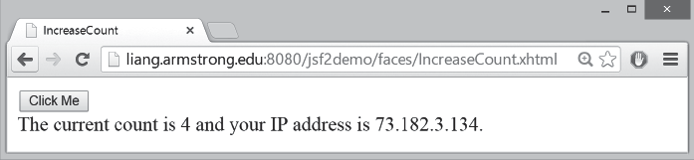
FIGuRE 39.25 The count is updated when the Click Me button is clicked.

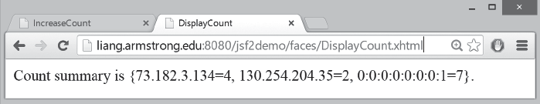
FIGuRE 39.26 The count for each client IP Address is displayed.



Listing 39.20 Track.java
1 package jsf2demo;
2
- import java.util.HashMap;
- import java.util.Map;
- import javax.enterprise.context.ApplicationScoped;
6
- @ApplicationScoped
- public class Track {
- private Map<String, Integer> map = new HashMap<>(); 10
- public void add(String ipAddress) {
- map.put(ipAddress, map.containsKey(ipAddress) ?
- map.get(ipAddress) + 1 : 1);
14 }
15
- public int getCount(String ipAddress) {
- return map.containsKey(ipAddress) ? map.get(ipAddress) : 0;
18 }
19
- public String getAllCount() {
- return "Count summary is " + map;
22 }
23 }

A Track object uses a map to store an IP address and its count with IP address as a key (line 9). The add method (lines 11–14) adds an IP Address to the map. If the IP address is not in the map, a new entry is created for the IP Address with value 1. Otherwise, the value for the IP address is incremented by 1 in the map. The getCount method (lines 16–18) returns the count for an IP address. If the IP address is not in the map, the method returns 0. The

application scope store counts

add or update count

return count

return all counts

39-42 Chapter 39 JavaServer Faces



process a click obtain count obtain IP address



obtain all counts
getAllCount method (lines 20–22) simply returns a string that describes the counts for all IP address in the map.
We now create a page named IncreaseCount.xhtml (Listing 39.21) with a button for displaying the number of times a button is clicked on the client, and create a page named Dis- playCount.xhtml (Listing 39.22) for displaying the counts from all clients.
Listing 39.21 IncreaseCount.xhtml
- <?xml version='1.0' encoding='UTF-8' ?>
- <!DOCTYPE html PUBLIC "-//W3C//DTD XHTML 1.0 Transitional//EN"
- "http://www.w3.org/TR/xhtml1/DTD/xhtml1-transitional.dtd">
- <html xmlns="http://www.w3.org/1999/xhtml"
- xmlns:h="http://xmlns.jcp.org/jsf/html">
- <h:head>
- <title>IncreaseCount</title>
- </h:head>
- <h:body>
- <h:form>
- <h:commandButton
- action="#{increaseCount.click()}" value="Click Me"/>
- <br>The current count is #{increaseCount.getCount()} and your
- IP address is #{increaseCount.getIpAddress()}.</br>
- </h:form>
- </h:body>
- </html>
Listing 39.22 DisplayCount.xhtml
- <?xml version='1.0' encoding='UTF-8' ?>
- <!DOCTYPE html PUBLIC "-//W3C//DTD XHTML 1.0 Transitional//EN"
- "http://www.w3.org/TR/xhtml1/DTD/xhtml1-transitional.dtd">
- <html xmlns="http://www.w3.org/1999/xhtml"
- xmlns:h="http://xmlns.jcp.org/jsf/html">
- <h:head>
- <title>DisplayCount</title>
- </h:head>
- <h:body>
- #{displayCount.getAllCount()}.
- </h:body>
- </html>
The IncreaseCount page uses the increasCount bean to process the click action (line 12), obtain the click count (line 13), and the client’s IP address (line 14). The DisplayCount page uses the displayCount bean to obtain the count from all clients (line 10). Both increas- Count and displayCount need to access the same track object. How can you create a Track object to be used by different objects? JSF supports context dependency injection (CDI) for injecting an object into a class using the @Inject annotation. Listing 39.23 gives the implementation for IncreaseCount.java and Listing 39.24 for DisplayCount.java.
Listing 39.23 IncreaseCount.java
- package jsf2demo;
2
- import javax.enterprise.context.SessionScoped;
- import javax.inject.Named;
- import javax.faces.context.FacesContext;
- import javax.inject.Inject;
- import javax.servlet.http.HttpServletRequest;
8
- @Named(value = "increaseCount")

Contexts and Dependency Injection 39-43

- @SessionScoped
- public class IncreaseCount implements java.io.Serializable {
- @Inject private Track track;
- private String ipAddress; 14
- public IncreaseCount() {
- HttpServletRequest request = (HttpServletRequest)FacesContext
- .getCurrentInstance().getExternalContext().getRequest();
- this.ipAddress = request.getRemoteAddr();
19 }
20
- public void click() {
- track.add(ipAddress);
23 }
24
- public String getIpAddress() {
- return ipAddress;
27 }
28
- public int getCount() {
- return track.getCount(ipAddress);
31 }
32 }
Listing 39.24 DisplayCount.java
1 package jsf2demo;
2
- import javax.enterprise.context.ApplicationScoped;
- import javax.inject.Named;
- import javax.inject.Inject;
6
- @Named(value = "displayCount")
- @ApplicationScoped
- public class DisplayCount {
- @Inject private Track track; 11
- public String getAllCount() {
- return track.getAllCount();
14 }
15 }
The @Inject annotation in line 12 of IncreaseCount.java and line 10 of DisplayCount.java injects a Track object. This Track object is created by the Java server container. The track data fields in both classes refer to this object.
In IncreaseCount.java, the constructor obtains the IP address of a client (lines 16 and 17) and sets it in the data field ipAddress (line 18). The click method adds the ipAddress to the map in the track object (line 22).
Note that the scope for Track and DisplayCount is ApplicationScoped since these two objects are created once for the entire application. However, the scope for Increase- Count is SessionScoped since each session has its own IP Address.

KEy TERMS
session scope inject track

increase count obtain client’s IP

add an IP address

count for an IP

application scope inject track obtain all counts



application scope 39-21 contexts and dependency injection
(CDI) 39-40
JavaBean 39-5
request scope 39-21
scope 39-21
session scope 39-21
view scope 39-21




39-44 Chapter 39 JavaServer Faces

CHaPTER SuMMaRy
- JSF enables you to completely separate Java code from HTML.
- A facelet is an XHTML page that mixes JSF tags with XHTML tags.
- JSF applications are developed using the Model-View-Controller (MVC) architecture, which separates the application’s data (contained in the model) from the graphical pres- entation (the view).

- The controller is the JSF framework that is responsible for coordinating interactions between view and the model.

- In JSF, the facelets are the view for presenting data. Data are obtained from Java objects. Objects are defined using Java classes.

- In JSF, the objects that are accessed from a facelet are JavaBeans objects.
- The JSF expression can either use the property name or invoke the method to obtain the current time.

- JSF provides many elements for displaying GUI components. The tags with the h prefix are in the JSF HTML Tag library. The tags with the f prefix are in the JSF Core Tag library.

- You can specify the JavaBeans objects at the application scope, session scope, view scope, or request scope.

- The view scope keeps the bean alive as long as you stay on the view. The view scope is between session and request scopes.

- JSF provides several convenient and powerful ways for input validation. You can use the standard validator tags in the JSF Core Tag Library or create custom validators.
QuIZ
Answer the quiz for this chapter online at the book Companion Website.

PROgRaMMINg ExERCISES
*39.1 (Factorial table in JSF) Write a JSF page that displays a factorial page as shown in Figure 39.27. Display the table in an h:outputText component. Set its escape property to false to display it as HTML contents.
*39.2 (Multiplication table) Write a JSF page that displays a multiplication table as shown in Figure 39.28.
*39.3 (Calculate tax) Write a JSF page to let the user enter taxable income and filing status, as shown in Figure 39.29a. Clicking the Compute Tax button computes and displays the tax, as shown in Figure 39.29b. Use the computeTax method intro- duced in Listing 3.5, ComputeTax.java, to compute tax.
*39.4 (Calculate loan) Write a JSF page that lets the user enter loan amount, interest rate, and number of years, as shown in Figure 39.30a. Click the Compute Loan Payment button to compute and display the monthly and total loan payments, as shown in Figure 39.30b. Use the Loan class given in Listing 10.2, Loan.java, to compute the monthly and total payments.



Programming Exercises 39-45
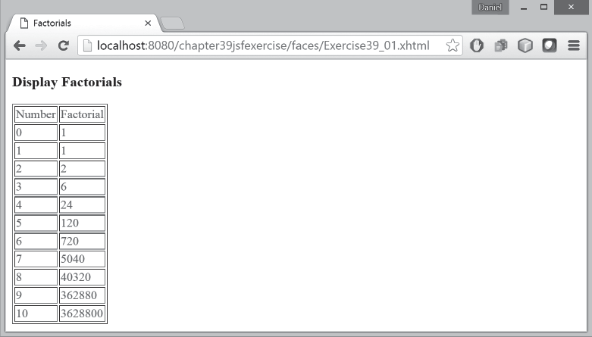
FIGuRE 39.27 The JSF page displays factorials for the numbers from 0 to 10 in a table.

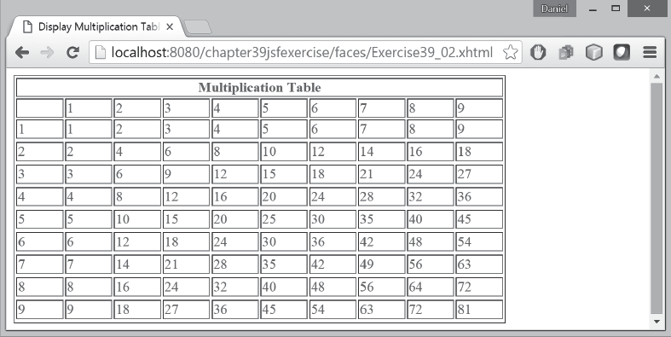
FIGuRE 39.28 The JSF page displays the multiplication table.

*39.5 (Addition quiz) Write a JSF program that generates addition quizzes randomly, as shown in Figure 39.31a. After the user answers all questions, it displays the result, as shown in Figure 39.31b.
*39.6 (Large factorial) Rewrite Exercise 39.1 to handle large factorial as shown in Figure 39.32. Use the BigInteger class introduced in Section 10.9.
*39.7 (Guess birthday) Listing 4.3, GuessBirthday.java, gives a program for guessing a birthday. Write a JSF program that displays five sets of numbers, as shown in Figure
39.33a. After the user checks the appropriate boxes and clicks the Guess Birthday
button, the program displays the birthday, as shown in Figure 39.33b.




39-46 Chapter 39 JavaServer Faces
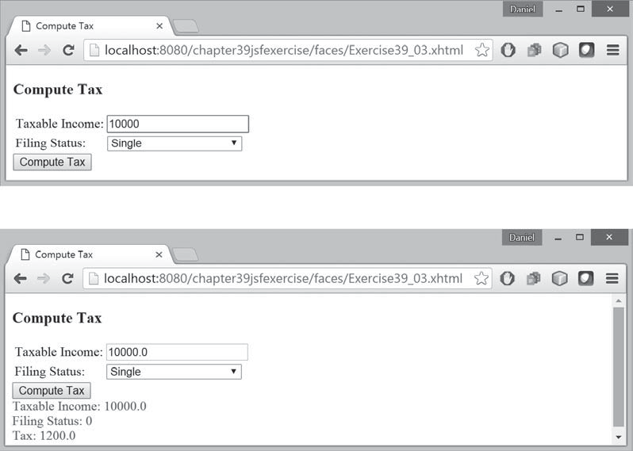
(a)
(b)
FIGuRE 39.29 The JSF page computes the tax.

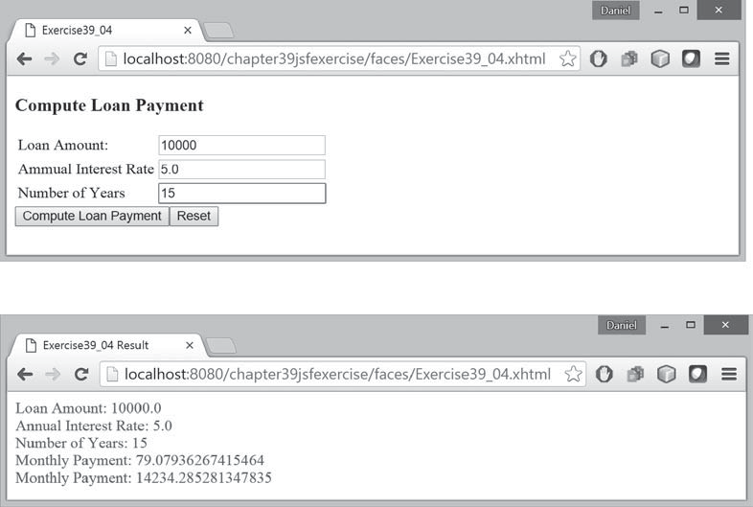
(a)
(b)
FIGuRE 39.30 The JSF page computes the loan payment.



Programming Exercises 39-47

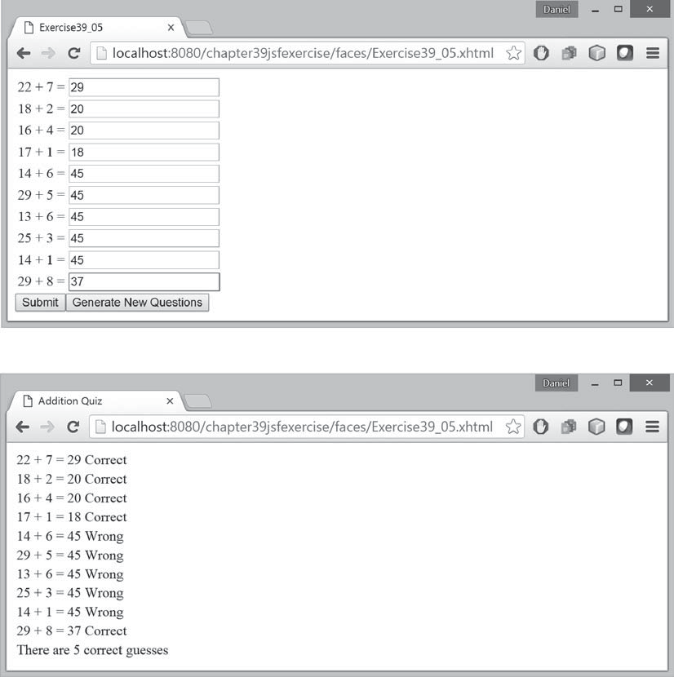
(a)
(b)
FIGuRE 39.31 The program displays addition questions in (a) and answers in (b).

*39.8 (Guess capitals) Write a JSF that prompts the user to enter a capital for a state, as shown in Figure 39.34a. Upon receiving the user input, the program reports whether the answer is correct, as shown in Figure 39.34b. You can click the Next button to display another question. You can use a two-dimensional array to store the states and capitals, as proposed in Exercise 8.37. Create a list from the array and apply the shuffle method to reorder the list so the questions will appear in random order.
*39.9 (Access and update a Staff table) Write a JSF program that views, inserts, and updates staff information stored in a database, as shown in Figure 39.35. The view button displays a record with a specified ID. The Staff table is created as follows:
create table Staff ( id char(9) not null,
lastName varchar(15), firstName varchar(15),



39-48 Chapter 39 JavaServer Faces
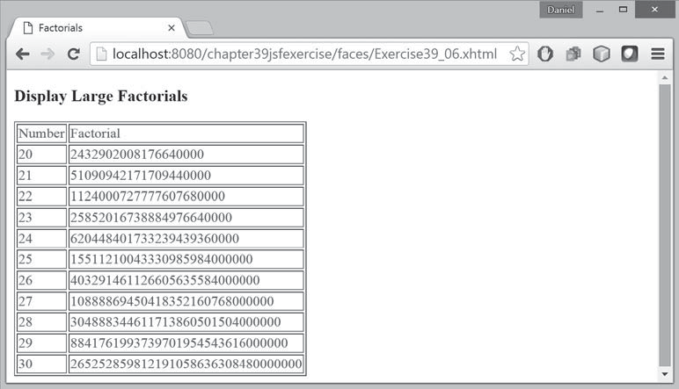
FIGuRE 39.32 The JSF page displays factorials for the numbers from 10 to 20 in a table.

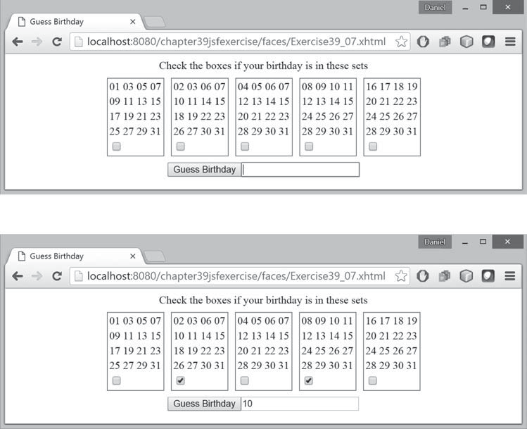
(a)
(b)
FIGuRE 39.33 (a) The program displays five sets of numbers for the user to check the boxes. (b) The program displays the date.



Programming Exercises 39-49
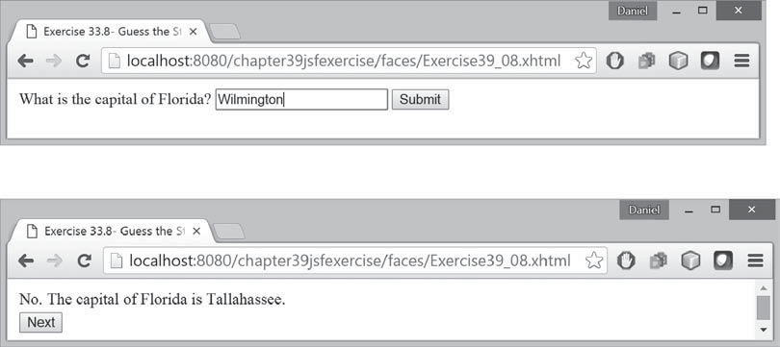
(a)
(b)
FIGuRE 39.34 (a) The program displays a question. (b) The program displays the answer to the question.

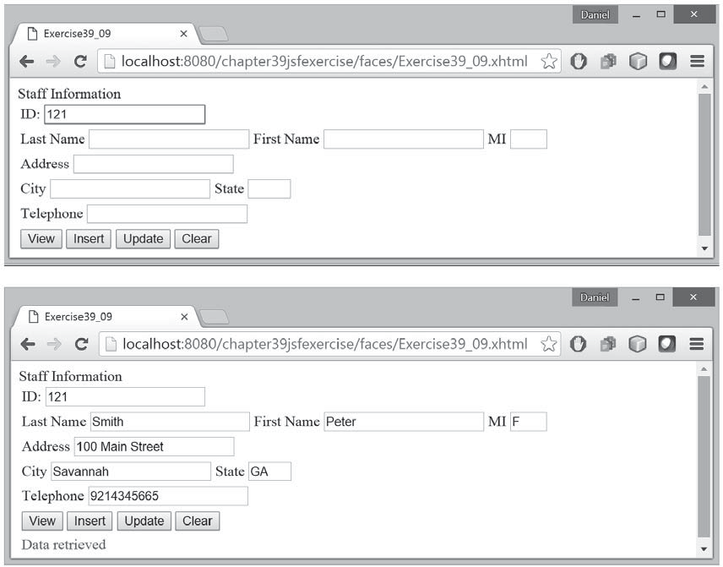
FIGuRE 39.35 The web page lets you view, insert, and update staff information.




39-50 Chapter 39 JavaServer Faces

mi char(1),
address varchar(20), city varchar(20), state char(2), telephone char(10), email varchar(40), primary key (id)
);
*39.10 (Random cards) Write a JSF that displays four random cards from a deck of 52 cards, as shown in Figure 39.36. When the user clicks the Refresh button, four new random cards are displayed.

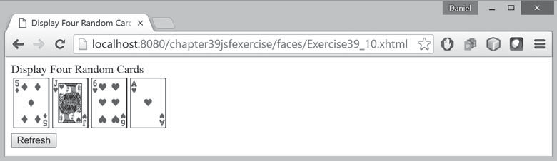
FIGuRE 39.36 This JSF application displays four random cards.

***39.11 (Game: the 24-point card game) Rewrite Exercise 20.13 using JSF, as shown in Figure 39.37. Upon clicking the Refresh button, the program displays four ran- dom cards and displays an expression if a 24-point solution exists. Otherwise, it displays No solution.

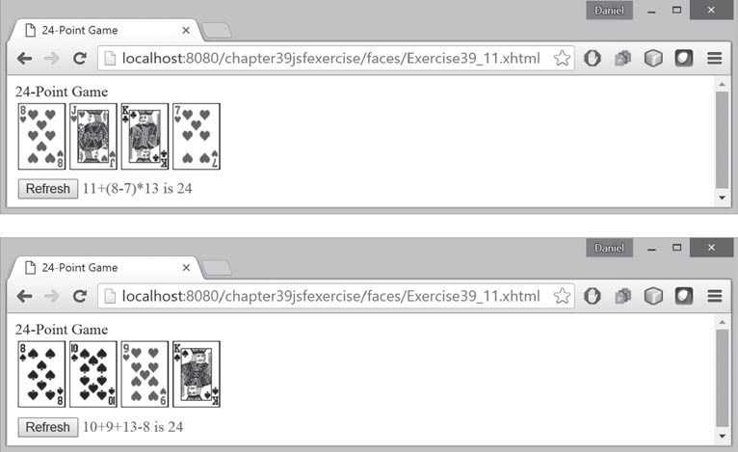
FIGuRE 39.37 The JSF application solves a 24-Point card game.




Programming Exercises 39-51
***39.12 (Game: the 24-point card game) Rewrite Exercise 20.17 using JSF, as shown in Figure 39.38. The program lets the user enter four card values and finds a solu- tion upon clicking the Find a Solution button.

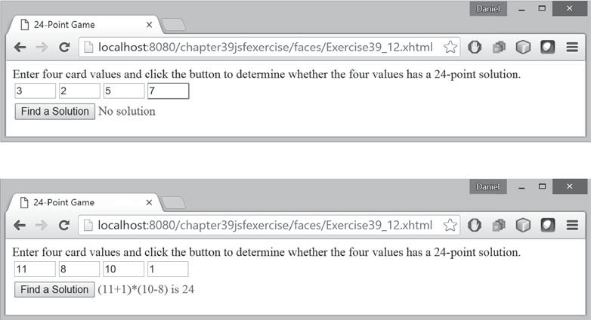
FIGuRE 39.38 The user enters four numbers and the program finds a solution.

*39.13 (Day of week) Write a program that displays the day of the week for a given day, month, and year, as shown in Figure 39.39. The program lets the user select a day, month, and year, and click the Get Day of Week button to display the day of week. The Time field displays Future if it is a future day or Past otherwise. Use the Zeller’s congruence to find the day of the week (see Programming Exercise 3.21).

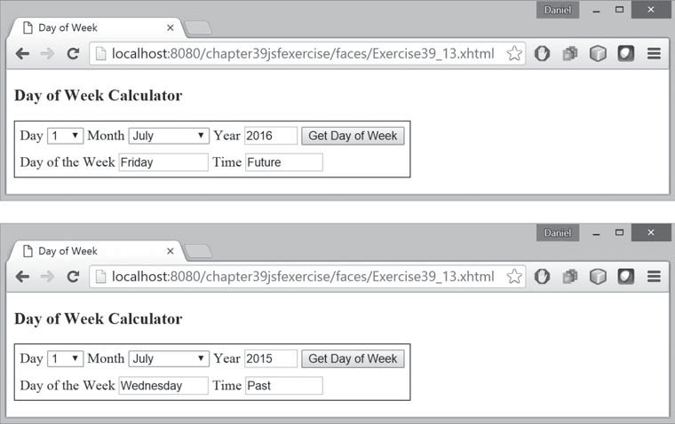
FIGuRE 39.39 The user enters a day, month, and year and the program finds the day of the week.




39-52 Chapter 39 JavaServer Faces
*39.14 (Display total count) Revise Listing 39.22 DisplayCount.xhmt to display the total count of the button clicks form all clients and display the client’s IP address and counts in increasing order of the counts, as shown in Figure 39.40.

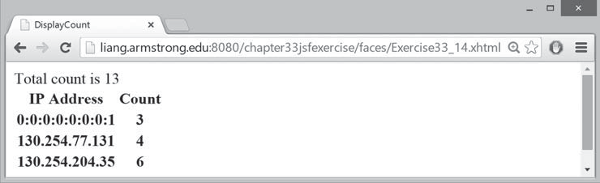
FIGuRE 39.40 The total counts and individual client counts are displayed.

